|  |
| --- |
| CO2104 CW2 |
| Gluten Freedom Evaluation |
| Autumn Bamford – ab1191@student.le.ac.uk |

|  |
| --- |
| Autumn Bamford |

Contents

Introduction 3

Background Technologies 3

Functionality 4

Accessible Choices 5

Walkthrough 6

Index/Title Page 6

Sign Up 7

Login 8

Reset Password 9

Home/Restaurant List 10

Restaurant Information 11

About 12

Map 13

Recommendations 14

Calendar 15

Account 16

Heuristic Evaluation and Usability Testing 17

About the responses 17

Example question 17

The heuristics and their ratings 18

Feedback Discussion 22

Visibility of System Status 22

Match Between the System and the Real World 22

User Control and Freedom 22

Consistency and Standards 22

Error Prevention 22

Recognition Rather than Recall 23

Flexibility and Efficiency of Use 23

Aesthetic and Minimalist Design 23

Help Users Recognize, Diagnose, and Recover from Errors 24

Help and Documentation 24

Extra Feedback 24

Conclusion 25

References 26

# Introduction

This website is based on collating and reviewing gluten-free restaurants throughout the Bristol area. The website is aimed at people unfamiliar and local to Bristol alike. My motivation behind making such a system is because I personally suffer with a gluten intolerance and have noticed how difficult it can be to find restaurants that accommodate my dietary needs, especially in areas I am unfamiliar with. My key requirements address this issue by including reviews specifically by those with gluten intolerance/celiac disease, displaying up-to-date restaurant menus, showing maps with exact locations, and allowing users to receive recommendations based on their activity to eliminate the struggle of deciding on a restaurant in an unknown area.

# Background Technologies

One external source I used in the development of my site was a Google Map API. This was used on the Map page to create an interactive, large-scale map that can be adapted later. Google’s map API allows web developers to very easily create custom maps and features to put on their site with minimal code, hence I thought it was suitable to use in this wireframe - it only required one line of code and a single JavaScript file.

Another external source I used is the FullCalendar JavaScript library. It was used on the Calendar page to create a mock calendar view that would represent how one would look on the final site. I chose to use it as it was simple to implement and had a clean look to it.

# Functionality

|  |  |  |
| --- | --- | --- |
| Function | Key Components | Justification |
| Login | Username and password input.  Enter button.  Validation. | The login feature provides a layer of security. It also allows the user to store data to a specific account. It has validation to ensure correct data is entered. |
| Sign Up | Username, email, and password input.  Enter button.  Validation. | Much like the login, it provides security and allows for the creation of an account. It has validation to ensure correct data is entered. |
| User Profile/Account | Username and user information.  Profile picture.  Edit and delete buttons. | The account feature allows users to have their personalised information and actions saved. This lets the site tailor content for recommendations and allows users to see their information on many devices. |
| Restaurant List | Restaurant names and information.  Links to restaurant page. | This feature is a core function of the site. It contains all the vital information for the users in a clear, list format. |
| Recommendations | Restaurant name and information.  ‘AI’ Reasonings.  Link to restaurant page. | This is my unique feature. It allows users to have a personalised experience on the site and promotes restaurants that users might not otherwise turn to. |
| Interactive Map | Large map view.  Fullscreen option.  Zoom In/Out. | This feature allows users to see to scale where certain restaurants are from their location. The full screen and zoom option allow visually impaired users to see in more detail. |
| Calendar | Current Date button.  Month Navigation  Event names, dates, and times. | The calendar gives users a minimalistic and understandable way to view all their bookings. It exists to improve the usability of the site. |
| Search Bar | Text input box.  Filler text. | The search bar allows users to directly find a specific restaurant or food without having to scroll endlessly. It improves the user’s experience. |
| Sort/Filter Buttons | List of options to choose from. | Similarly to the search bar, it allows the users to find specific types of restaurants to improve the user experience. |
| Restaurant Page | Restaurant name and information.  Images.  Map and location.  User Reviews. | The restaurant page view provides further context and information to a user without filling up the restaurant list view. It is visually easier to read compared to the compact list. |
| Reviews | Username.  Whether user is intolerant or celiac.  Review content. | The review function allows users to gain insight on restaurants and make more informed choices. It promotes being social on the website which encourages users to return. Reviews also provide authentic, personal information that instils a sense of trust in the site. |

# Accessible Choices

One accessible design choice I made was my use of colour. The website has a continuous colour scheme, where all of the colours chosen have a contrast that is acceptable by the Web Content Accessibility Guidelines (WCAG). This means that regardless of what type of colour-blindness a user might have, the text will always be readable.

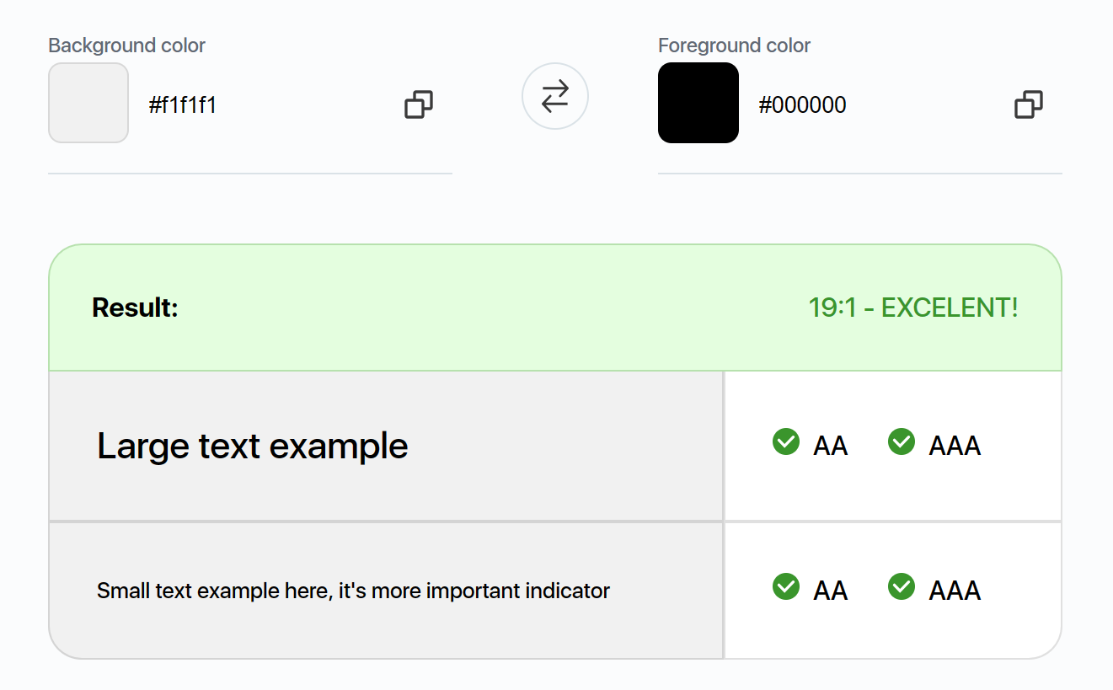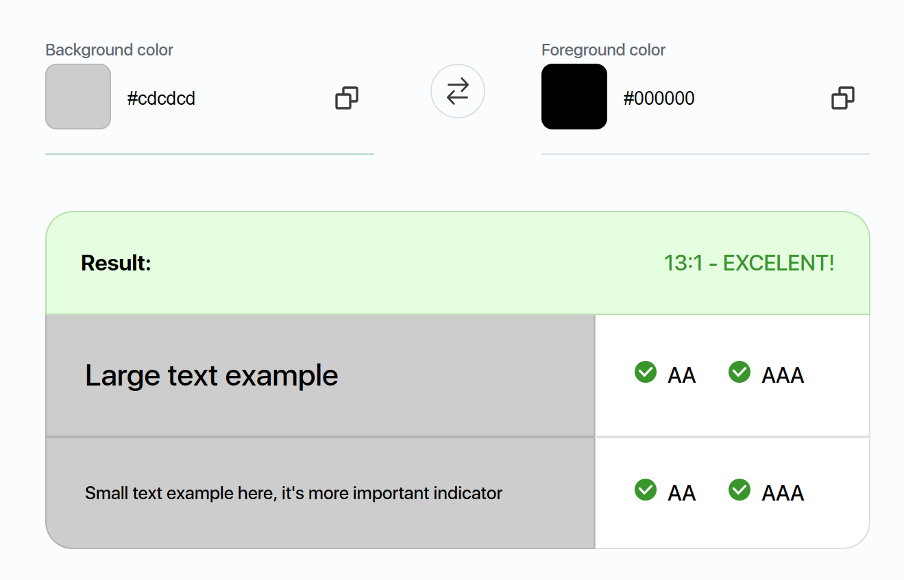

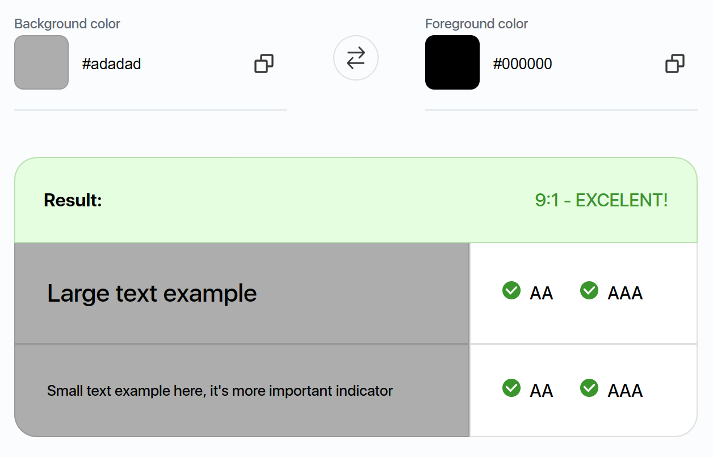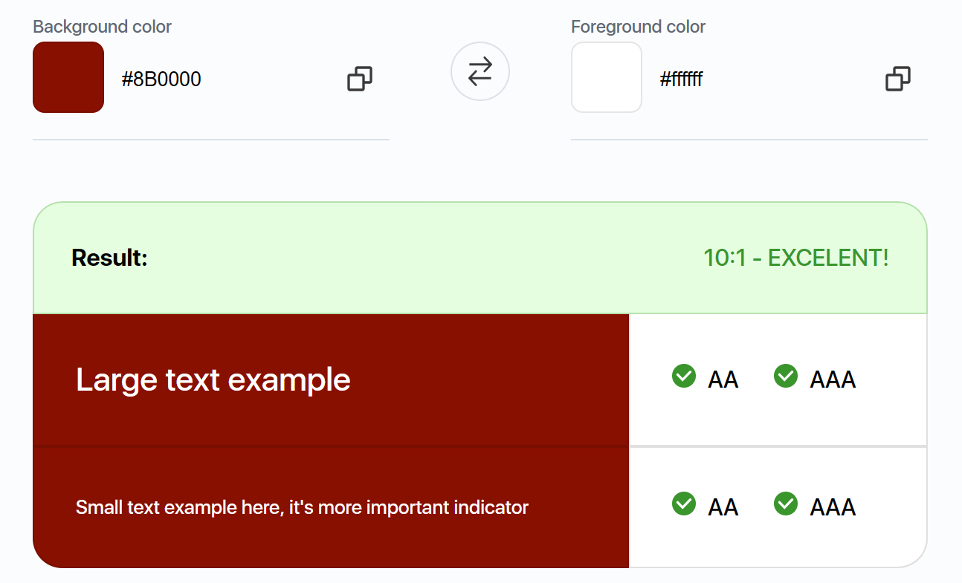

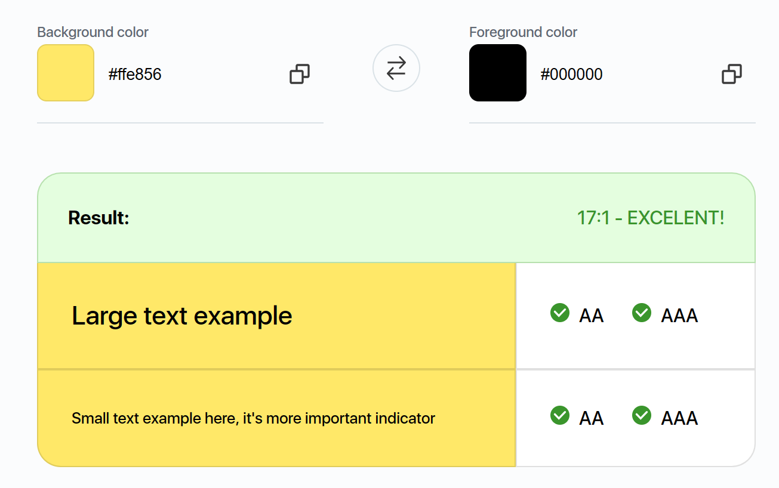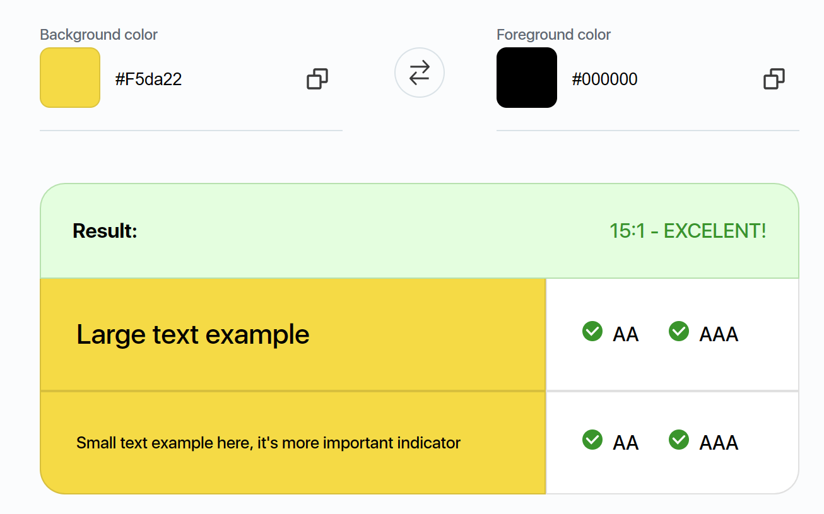

Another accessibility choice I made was my font size. According to the WCAG AA, the minimum font size should be 12px, and to the WCAG AAA it should be 18px. To this compliance, nearly all of my pages have a font size of over 18px. The only exception is the Restaurant List page, which has text that is 14px. However, the information that is in 14px is repeated in the Restaurant page in 20px. This means that all information in my site can be viewed in a WCAG AAA acceptable format.

# Walkthrough

## Index/Title Page

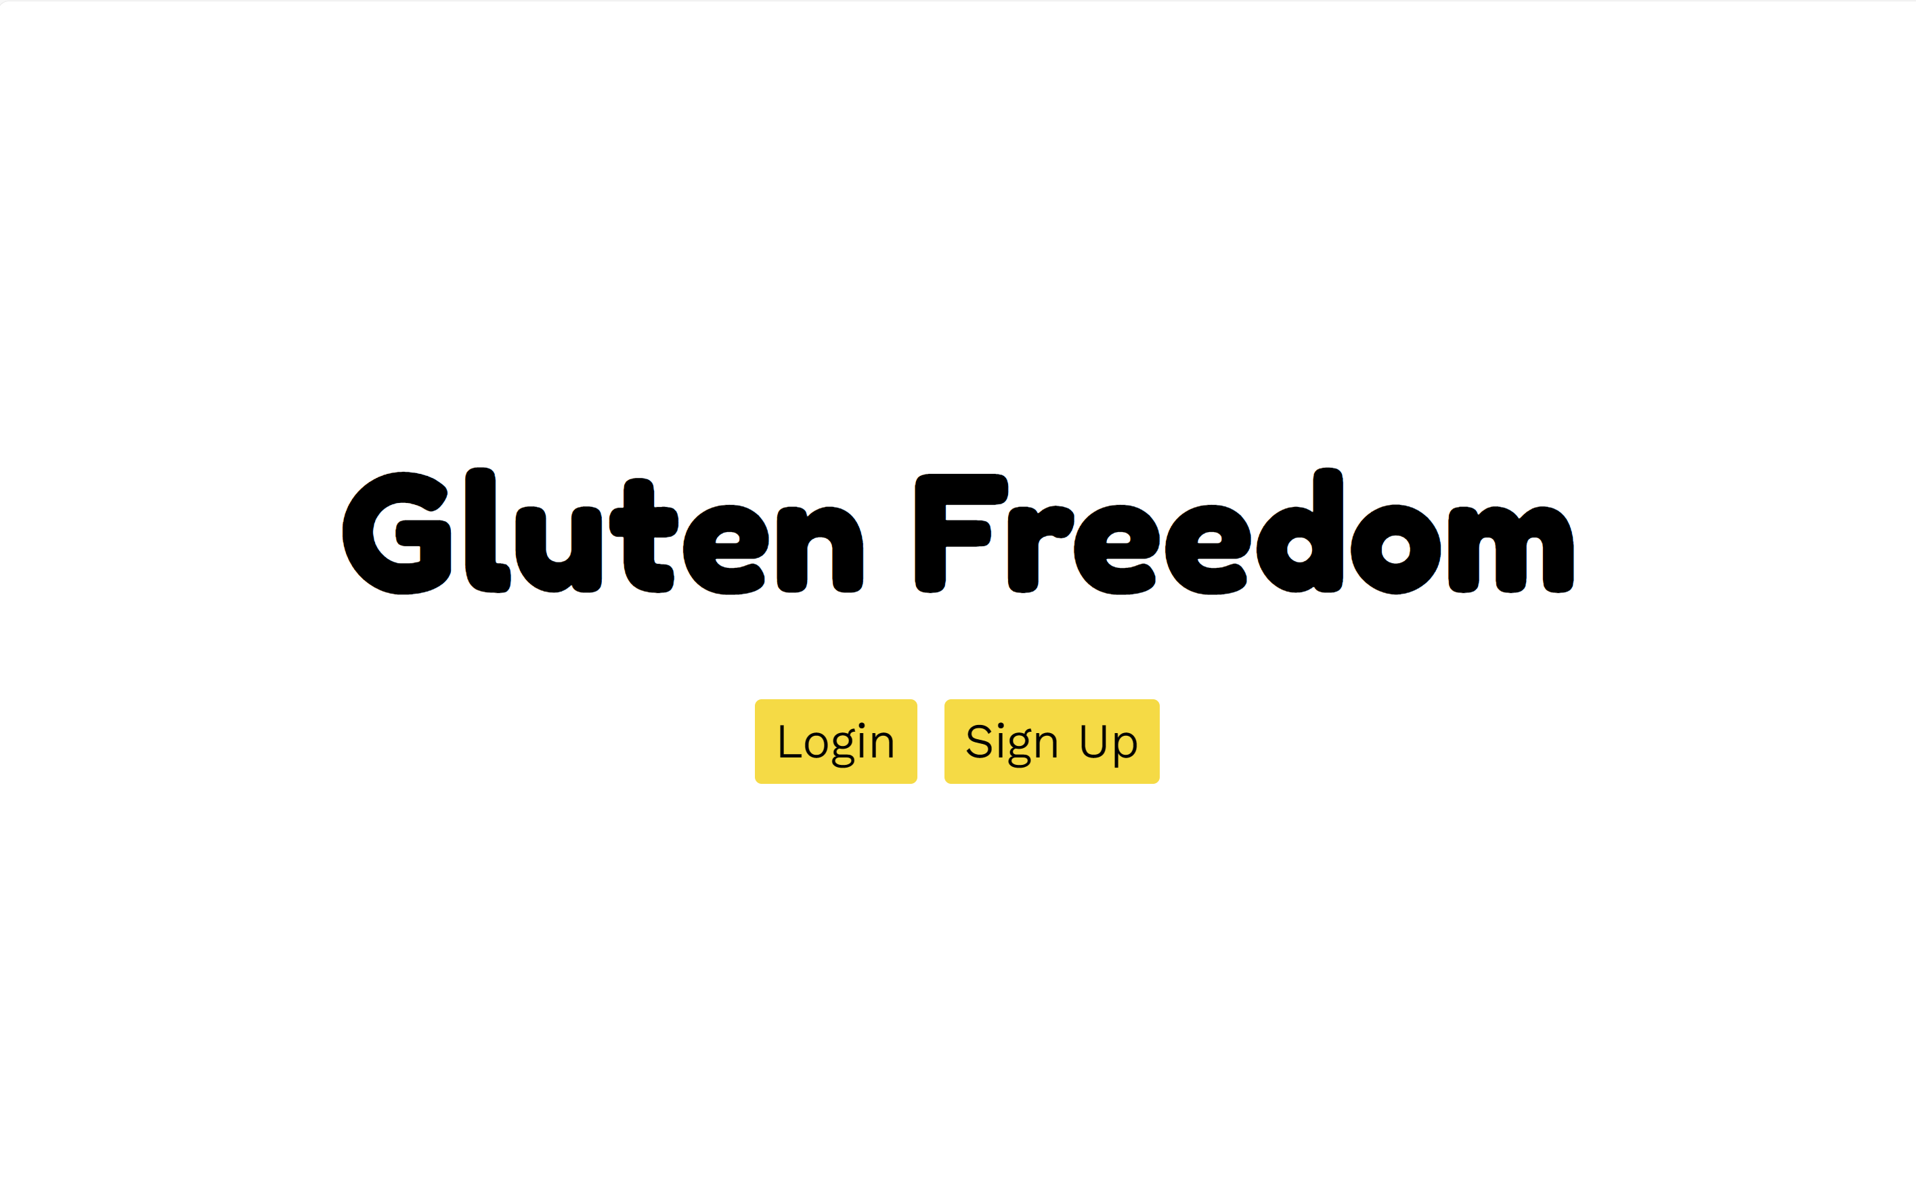

This page is the main title page that allows users to either login or sign up to the site. Each button redirects the user to the relevant page.

The page has a very simplistic design with bold, large fonts so that even users with visual impairments can clearly read all text. The colour accessibility is shown in the prior section.

## Sign Up

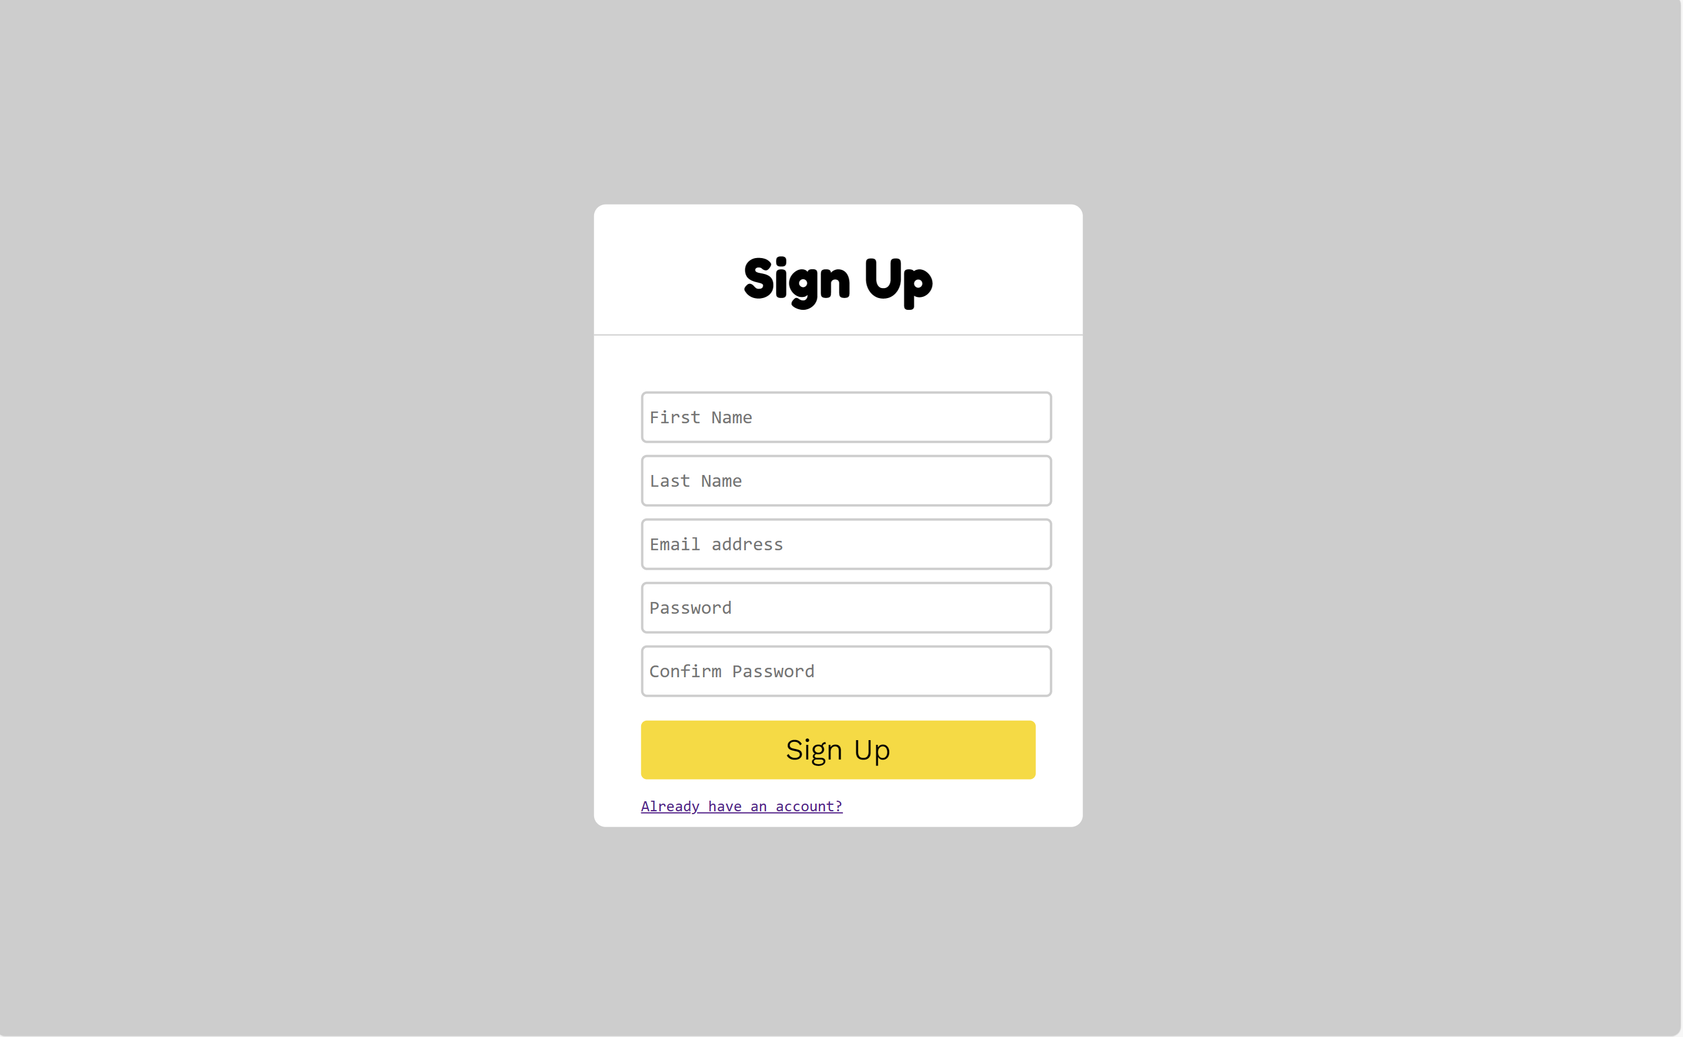

The sign-up page is where the users can create an account to access the site. It has multiple input boxes corresponding to a first and last name, an email, and a password. The sign-up page also validation coded in so that the users cannot type in incorrect information.

Given the information in the input boxes is there and validated, the ‘Sign Up’ button directs the user to the Home page. The ‘Already have an account?’ button directs the user to the Login page.

To ensure this page is accessible as possible, I’ve made sure all colours used comply with the WCAG, as shown here. Furthermore, I provide information about any errors clearly on the screen with a bold exclamation mark.

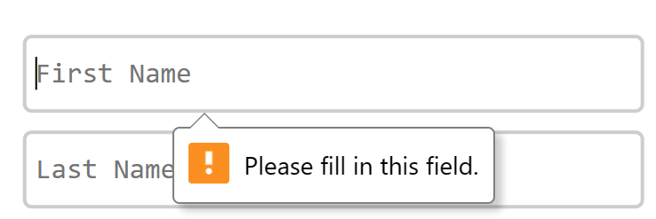

## Login

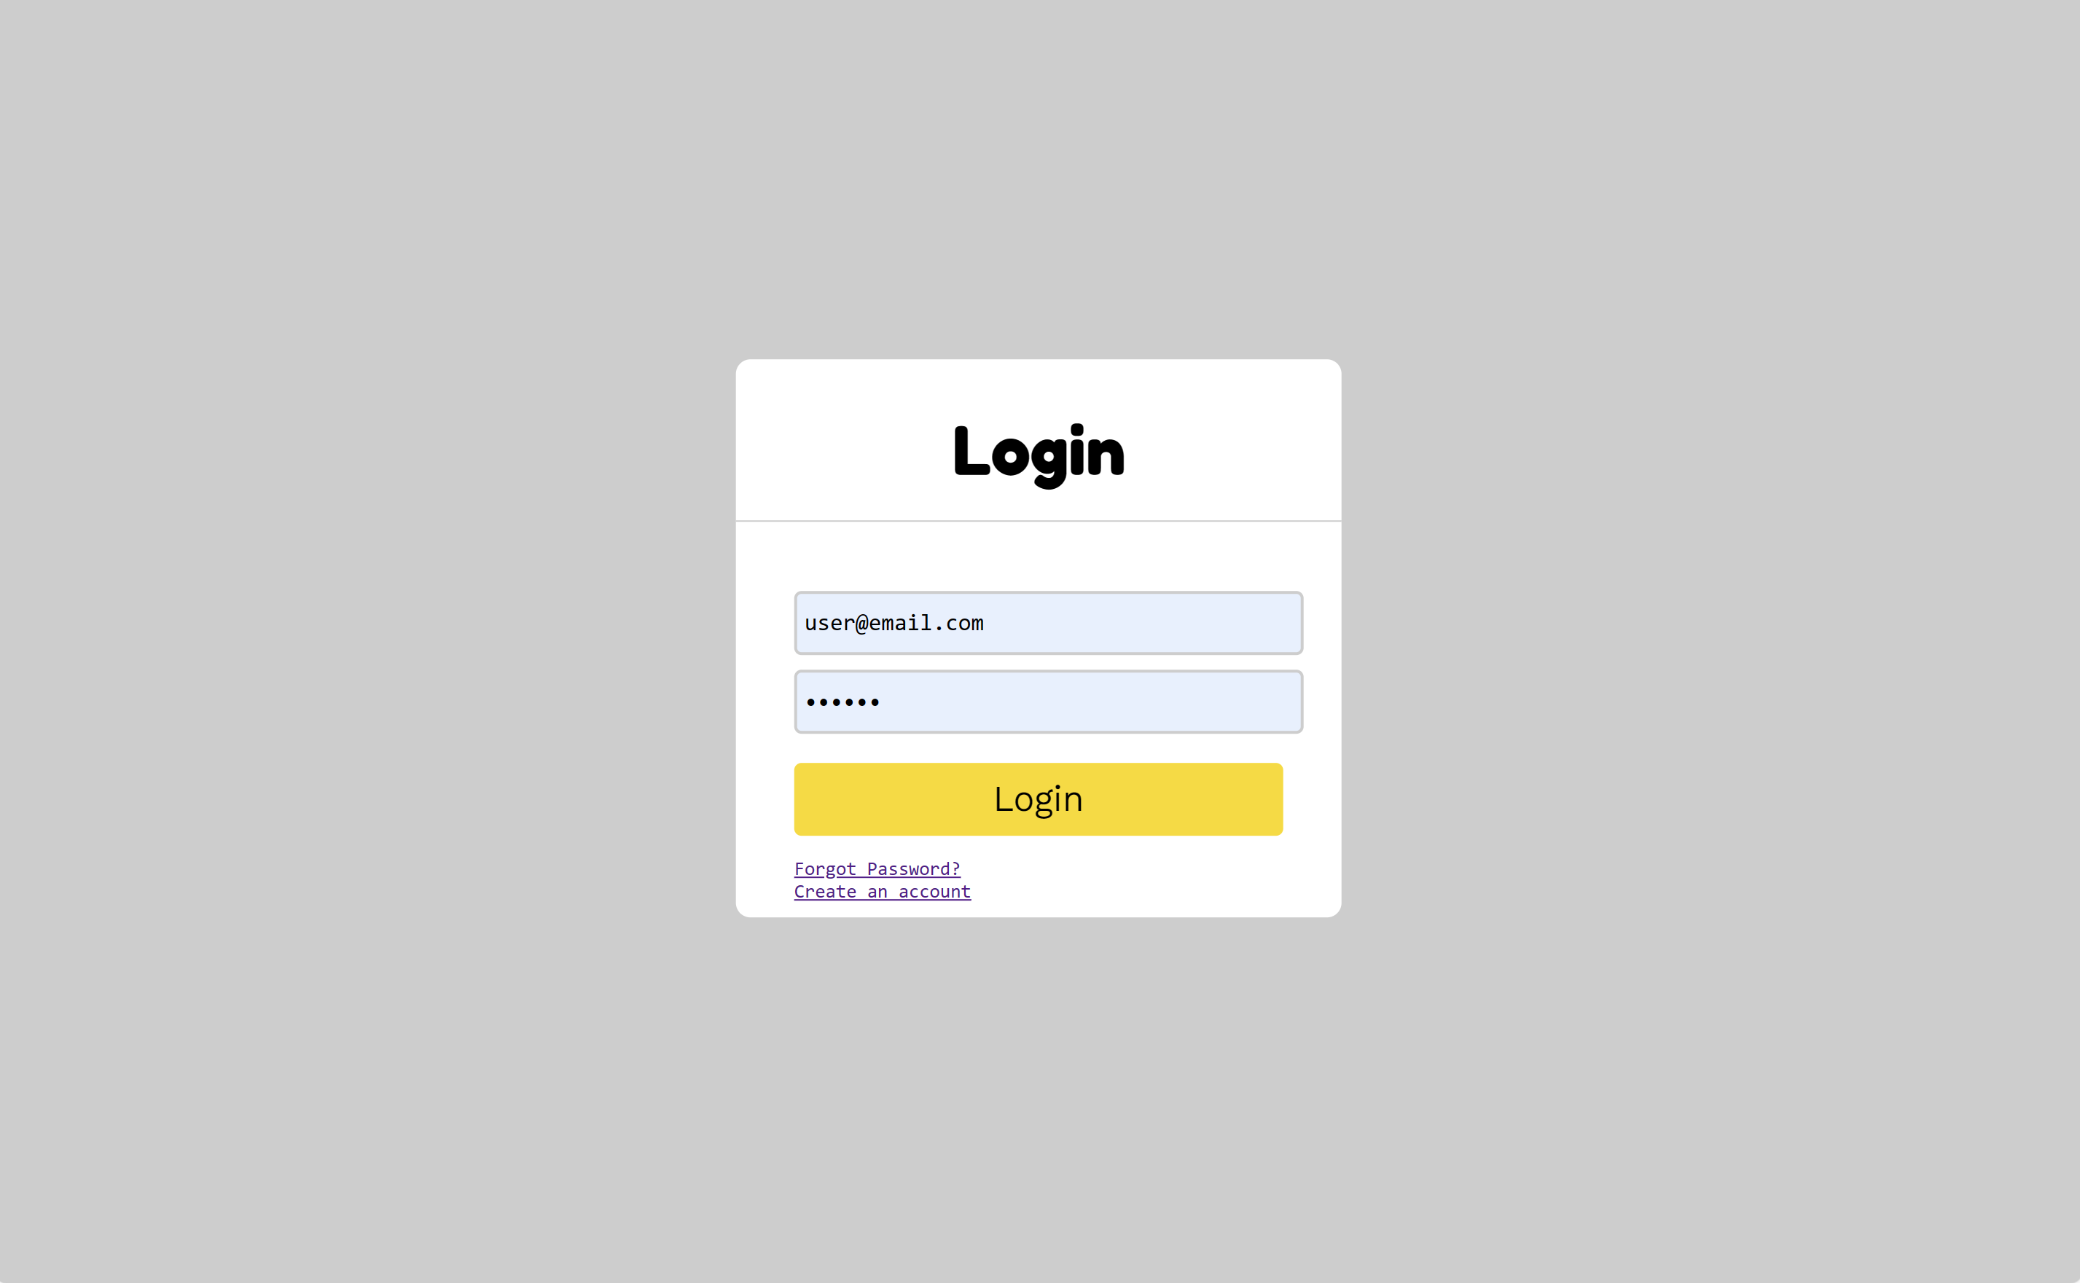

The Login page allows the user to sign into their account. As most of the information on the site is custom to the user (Recommendations, Account, Calendar etc.), the user must log into an account before the can gain access. The image above shows an example email and password. The password is censored for security.

There are three buttons on this page. First is the ‘Login’ button which directs the user to the Home page of the site. Next, there is the ‘Forgot Password?’ button which directs the user to the Reset Password page. Lastly, there is the ‘Create an account’ button which directs the user to the Sign-Up page.

The accessibility choices here are the same as that for the Sign-Up page.

## Reset Password

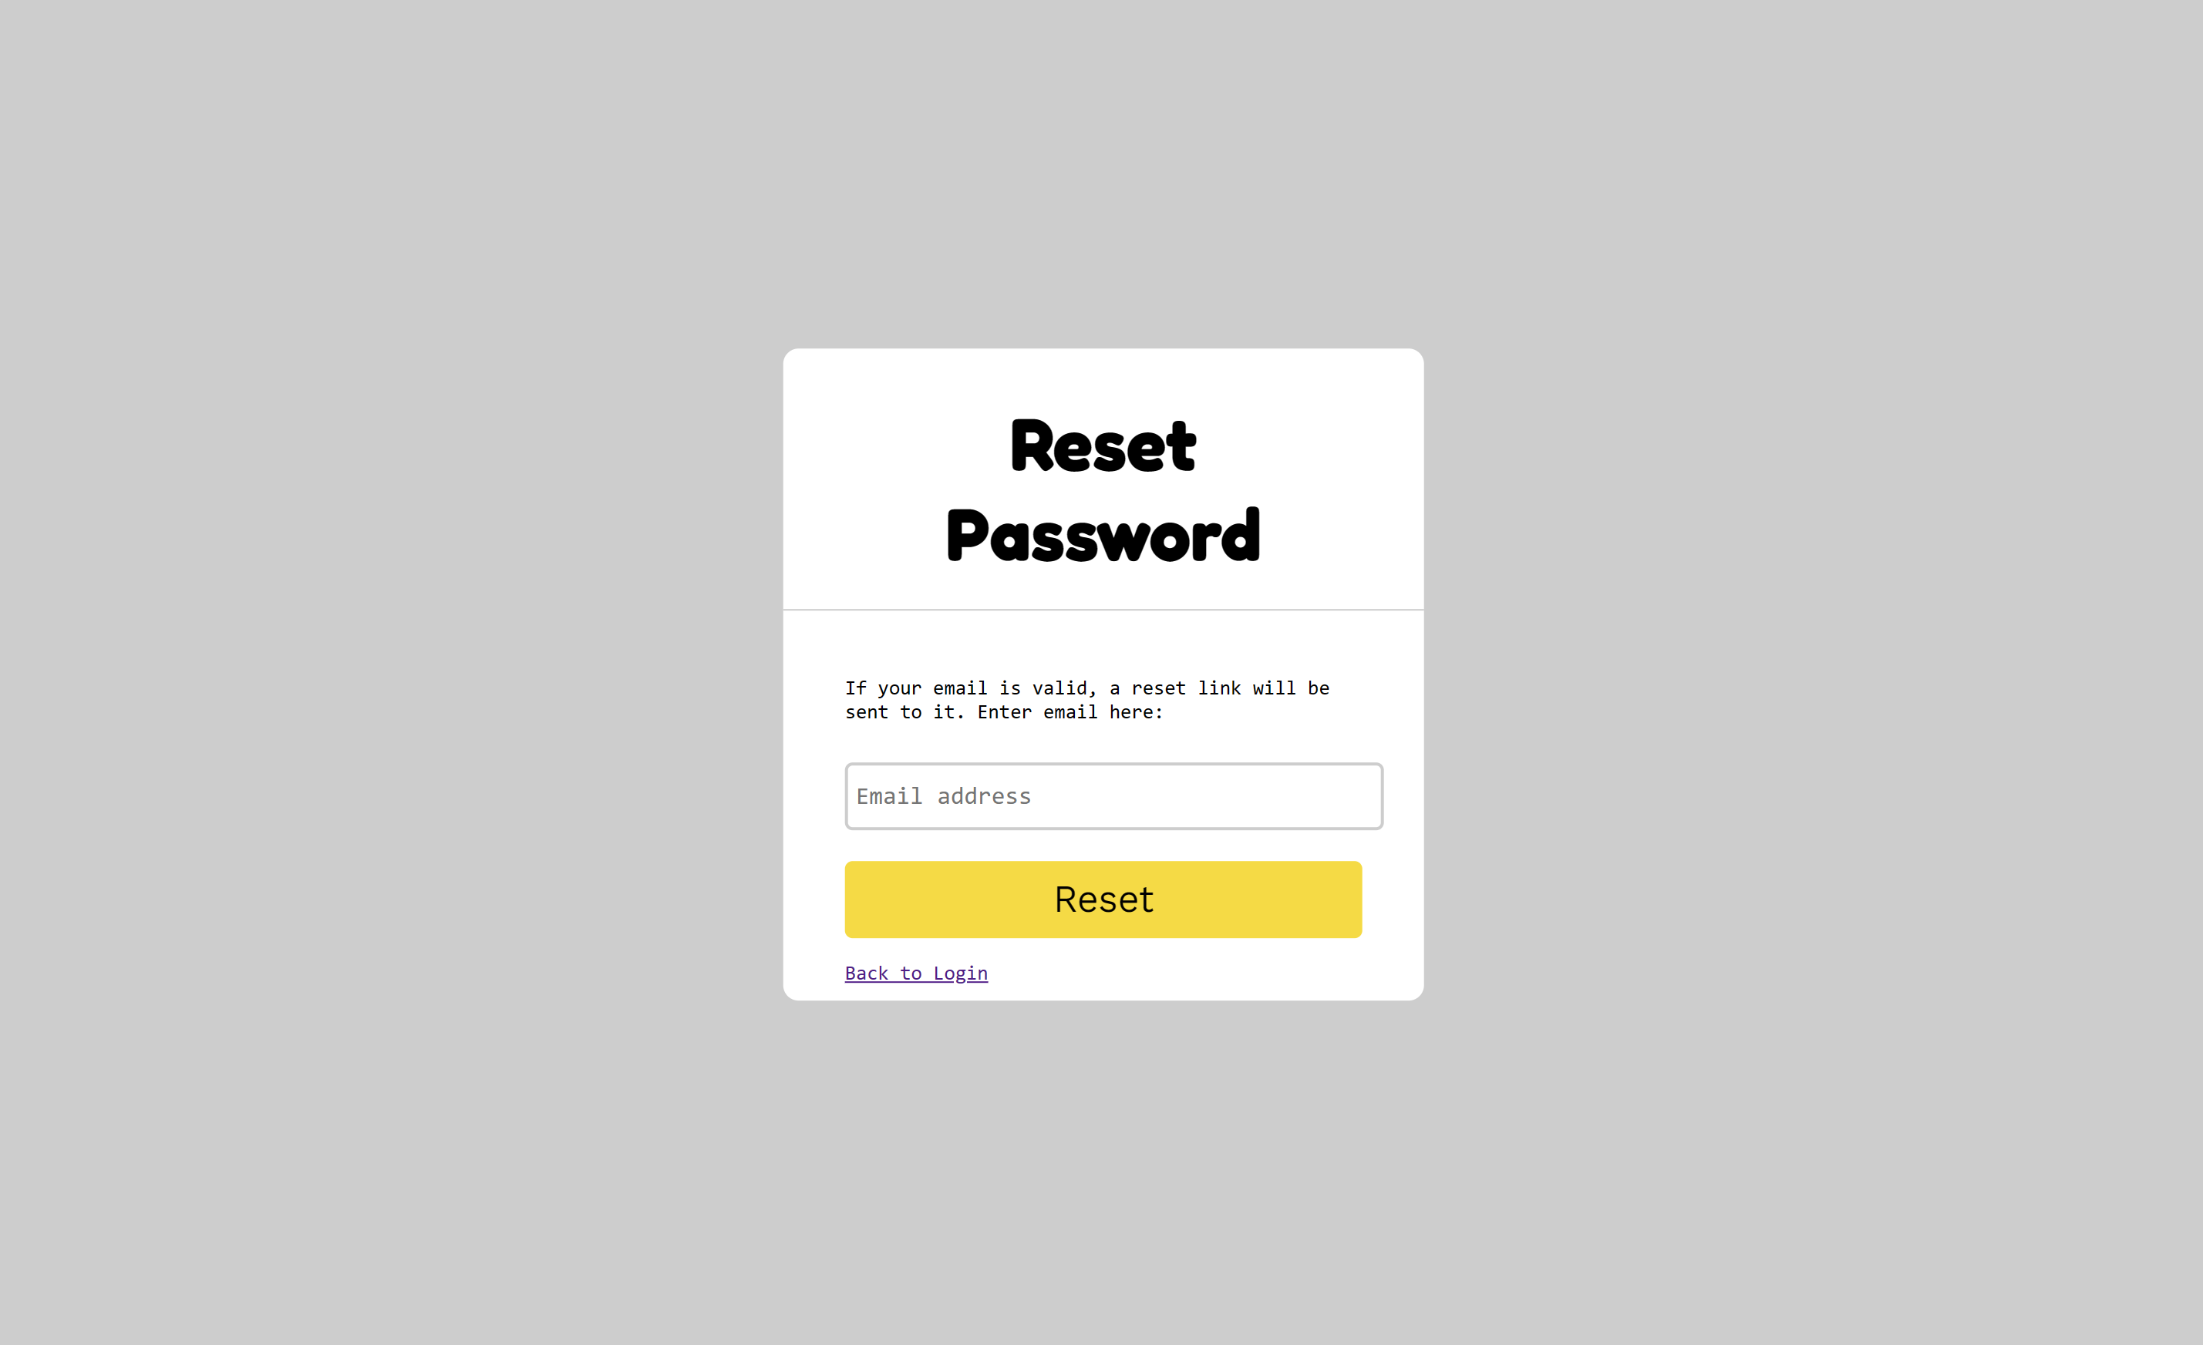

The reset password page would allow users to create a new password if they had forgotten theirs. It would do this by sending a reset link to the email they signed up with. Above the email input box is a short line of text explaining what the page is for and how it works.

There are two buttons on this page for navigation. First, there is the ‘Reset’ button which would send the reset email to the user. Next there is the ‘Back to Login’ button which directs the user back to the Login page.

The accessibility choices made here are the same as the previous forms.

## Home/Restaurant List

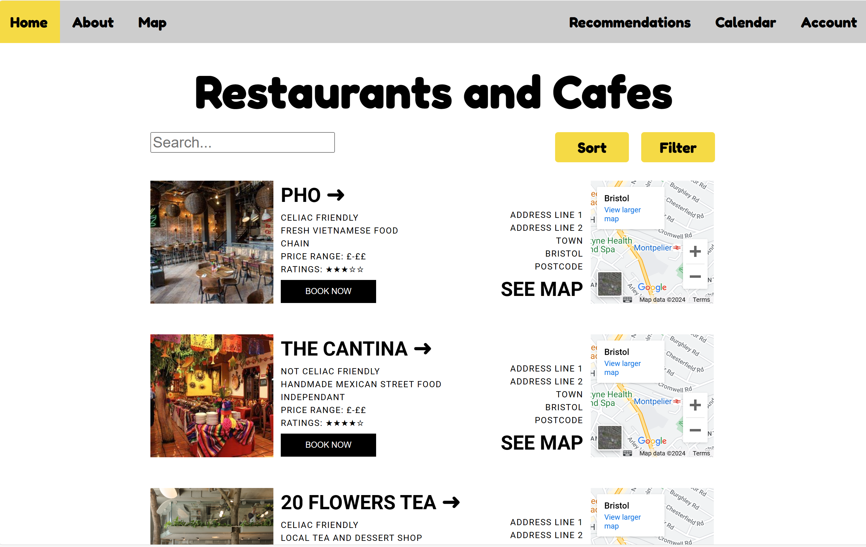

Clicking on the image or title takes the user to the Restaurant’s page.

Clicking on ‘Sort’ or ‘Filter’ opens a menu of options they can choose from.

‘BOOK NOW’ takes the user to the restaurants own booking form.

By clicking on the see map they can access the actual Google map for the restaurant. In a live version, there wouldn’t be the ‘View Larger Map’ option on the actual map as it blocks the view.

Search bar allows the user to find restaurants by key words or terms.

Users can access other pages via the navbar. The yellow option is the current page.

This page is the homepage of the site, but also is a list of all restaurants on the site. Users can use this page to search for, sort, and filter restaurants. It provides an overview of all the restaurants that are considered gluten-free or celiac friendly.

Each restaurant on this page has a link to their restaurant page on the site, a link to the restaurants booking form, a small interactive map so users can quickly understand the location, and finally a link to the actual Google map for the restaurant. At the top of the page is also a navbar that allow users to access other pages on the site such as the Calendar and Account pages.

The accessibility choices made here are the same as the other pages. However, it is of note that the information under the restaurant title can be slightly difficult to read for those with visual impairments, but this same information is repeated in a larger font on the individual restaurant page. Other accessibility choices are that all images have alternative text. A potential accessibility issue might also be with my decision to use “iframe” elements, however after research I discovered they minimal accessibility issues (WebAIM, 2020) (Singleton, 2021).

## Restaurant Information

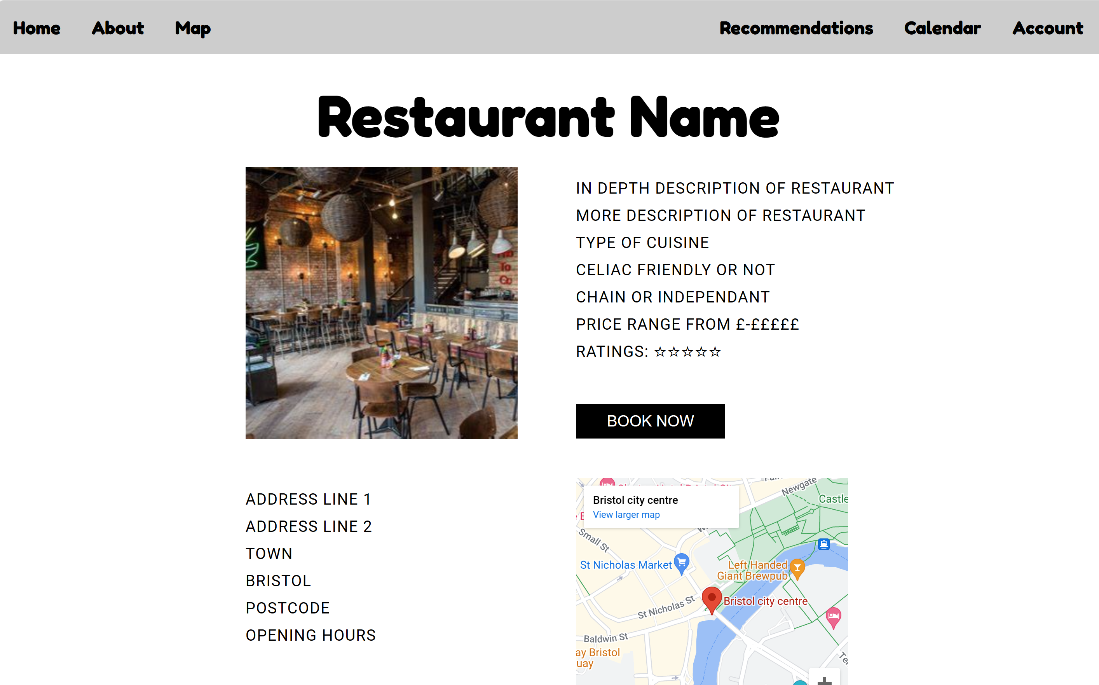

Users can access other pages via the navbar. There is no yellow selection right now as this page isn’t accessible by the navbar – only the restaurant list and recommendations.

‘BOOK NOW’ takes the user to the restaurants own booking form.

Iframe of small interactive map. Also takes users to a larger interactive map.

States whether restaurant is celiac friendly or just gluten intolerance friendly

This page is to display further information about a specific restaurant. It has a link to a book button, the address, a small interactive map, and reviews left by other users on the site. One small but important feature is that, like the restaurant list, the restaurant states whether it is completely celiac friendly or not. This is important as celiac can be a deadly allergen, and whilst some restaurants offer gluten free food it can sometimes be cross contaminated within the cooking process. Therefore, it is a necessity for celiacs to eat somewhere with no cross contamination. The reviews, as shown below, also make note of whether the reviewer is celiac or not as this can affect the dining experience.

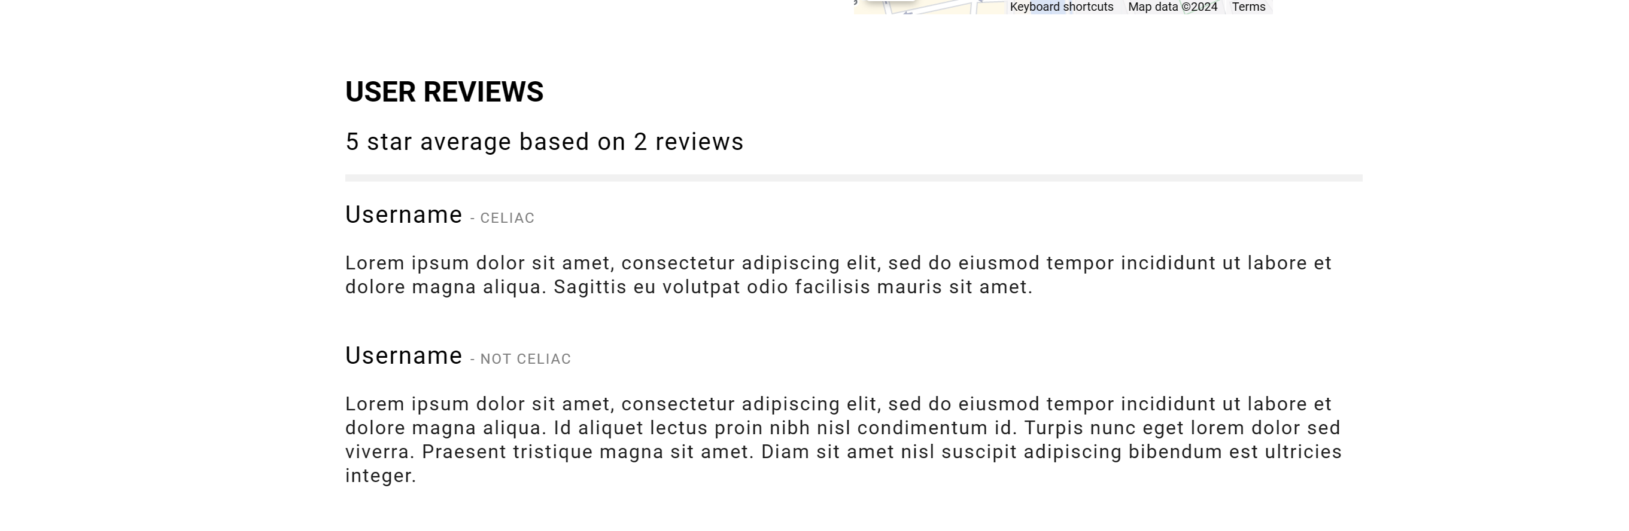

Other than the ‘Book Now’ button, the only other navigation on this page is the navigation bar at the top of the screen. As on the list page, all images have alternative text, the page has thought out colour choices, and the iframe doesn’t pose issues according to online resources on web accessibility.

## About

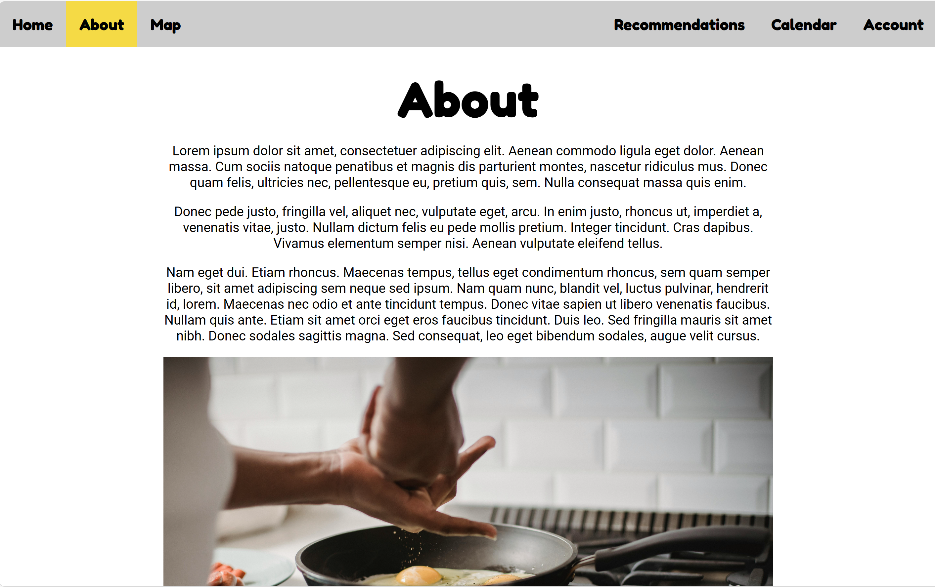

The About page would hold all the information about why the site was created, what qualifies a restaurant as gluten free and how they get added to the site, as well as any further information about the site and its creation that users might find useful. As the site isn’t live, this information has instead been replaced with filler text. Also on the page are buttons that would act as links to social media.

Besides the buttons to the respective social media sites, the only other navigation on the page is the navigation bar at the top.

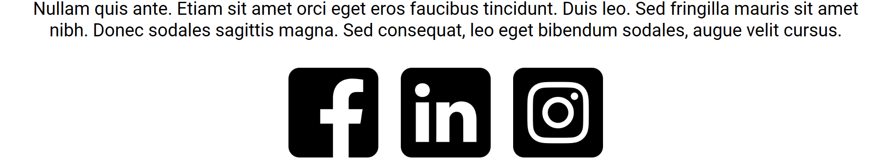

As the buttons are PNG files, they also have alternative text, as does the image in centre of the screen. The icons chosen are also in black and white, so they are clearly visible to most people with visual impairments. All other accessibility choices are described in the accessibility portion of the evaluation.

## Map

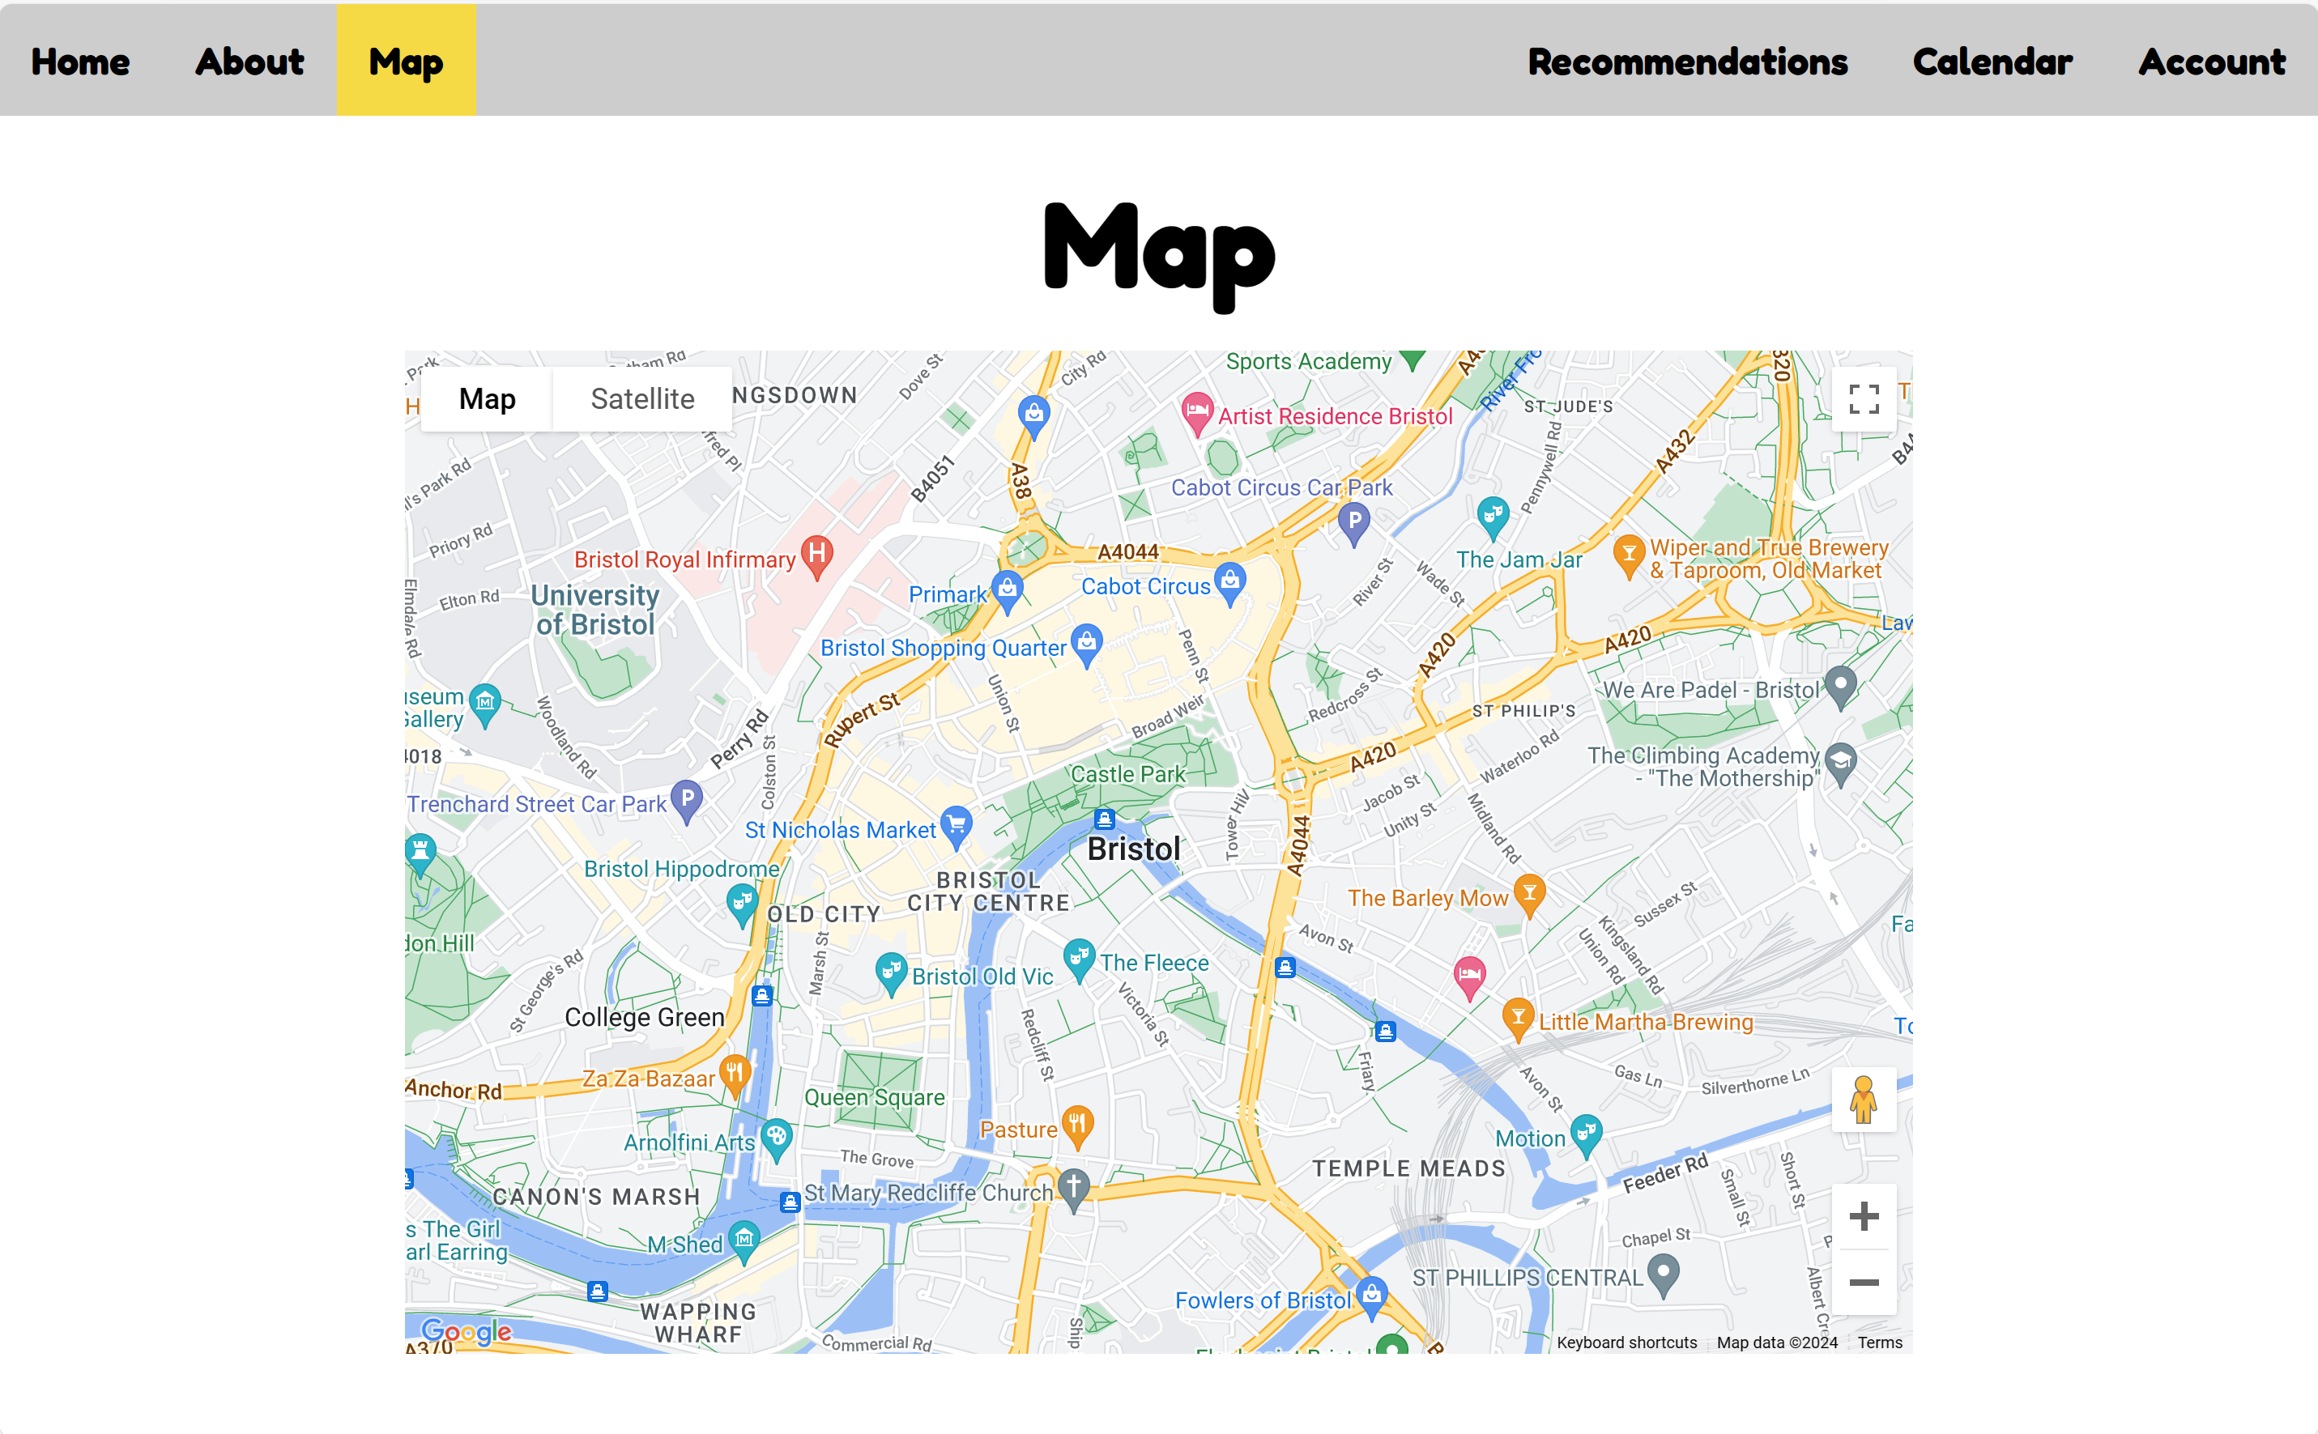

Allows users to zoom in or out of the map view.

Allows users to make the map view full screen.

Allows users to change between the more minimalist map view or satellite view.

Users can access other pages via the navbar. The yellow option is the current page.

The map page serves to show a live view of all the restaurants on the site as well as the users location. That way, if a user wanted to find a restaurant by distance or location, it would be very simple. The map can be turned full screen, can have a minimalist or satellite view, or can be zoomed in and out. These are all features included by using the Google Map API.

The only navigation on the page currently is the navigation bar at the top of the screen. If the site was live, it would include pointers for all the restaurants, which could then take the user to the restaurants page or own website.

As far as accessibility goes, it is dependant on how much accessibility Google has put into their maps. However, according to research I have done, markers you can set on the maps can be given descriptive text that can be read by screen readers, and can also be increased in size for those with visual impairments – albeit at the cost of location precision (Google, 2024). Furthermore, according to a Google Maps Tech Lead, there is work being put in to improve the accessibility of the Google Maps API (Shull, 2021).

## Recommendations

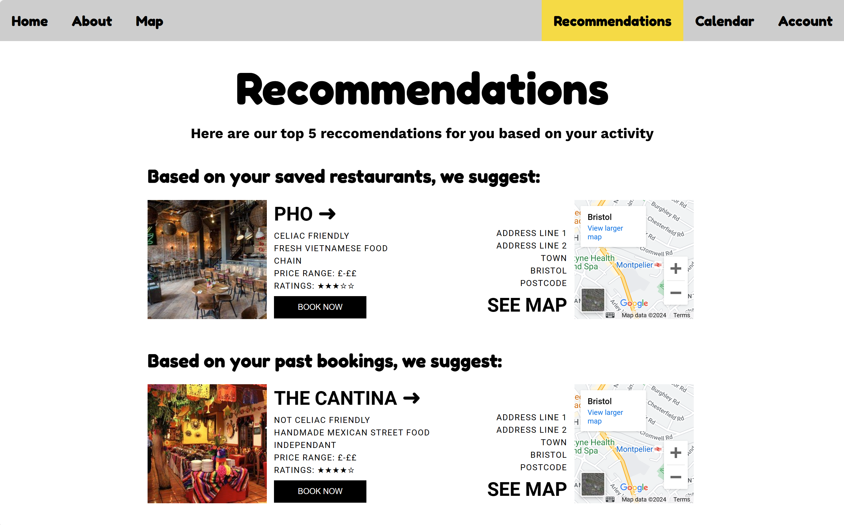

The headers inform the user of why the specific restaurant was suggest + gives insight on how their choices are impacting recommendations.

Users can access other pages via the navbar. The yellow option is the current page.

‘BOOK NOW’ takes the user to the restaurants own booking form.

Clicking on the image or title takes the user to the Restaurant’s page.

By clicking on the see map they can access the actual Google map for the restaurant. In a live version, there wouldn’t be the ‘View Larger Map’ option on the actual map as it blocks the view.

This page is my unique feature for the site. Whilst this version is a prototype, the live version would use AI to recommend restaurants to users based on their interactions with the site. It takes information such as reviews, bookings, location, preferences, and even weather to formulate five random suggestions for the user. The suggestions would change as the users’ activity changes, and the prompts can be unique too.

The functionality on this page is the exact same as the Restaurant List page, except with only five restaurants. As such, there is no search bar, nor any sort/filter functionality either. Instead, there are the headers which informs the user as to why this restaurant was recommended to them.

The accessibility choices made are the same as the other pages throughout the site.

## Calendar

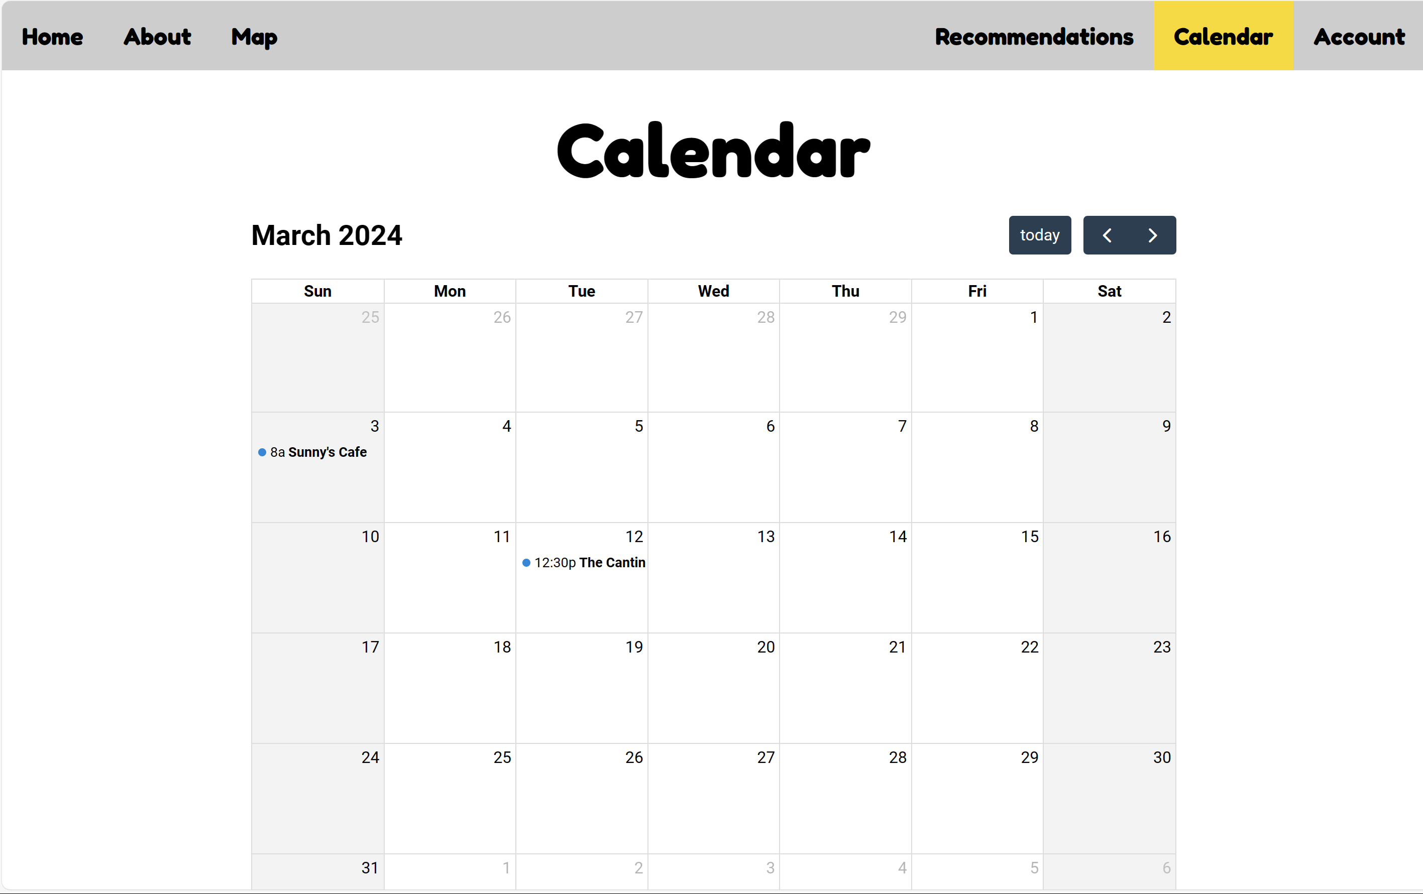

Entries tell users the time of the booking and where.

The ‘today’ button takes the user to the current date.

The arrows allow users to switch between different months.

Users can access other pages via the navbar. The yellow option is the current page.

The Calendar page allows users to view all their past and upcoming bookings in clear, minimalist way. The calendar is automatically updated whenever a user confirms a booking and will update whenever they change the time or date of a booking too. It has buttons that switch between the months, as well as a button that returns the user to todays date.

The only way to navigate to other pages on the site is via the navigation bar at the top.

This page was made using FullCalendar JavaScript library. As far as accessibility goes, FullCalendar can be made somewhat more accessible (FullCalendar, 2024), but by default it is lacking. Due to my lack of experience with FullCalendar, I was not able to add as many accessibility options as I would like, this this is something I am to change in the future.

## Account

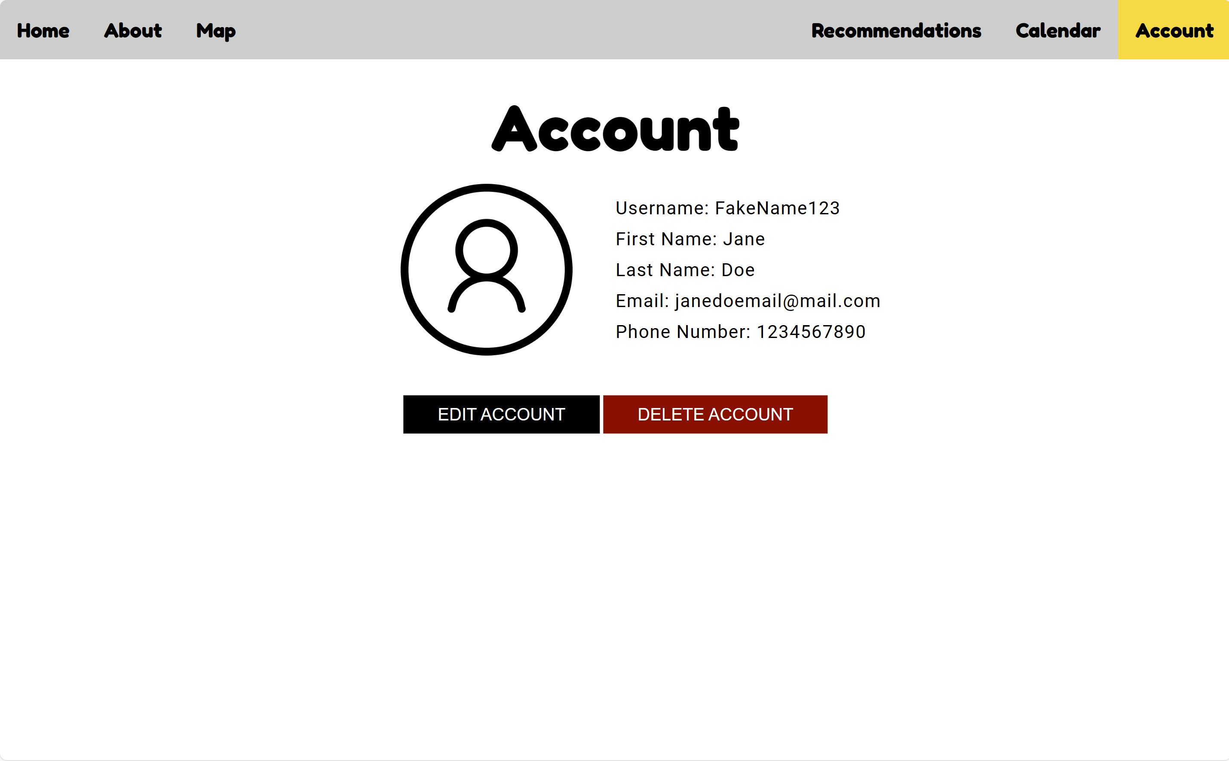

Shows the user their profile picture and their current information.

Users can access other pages via the navbar. The yellow option is the current page.

Options to delete or edit account.

The account page allows users to view their information, edit their information, and delete their account. The edit account button would allow users to change their profile picture, their username, and their contact details. Delete account would allow users to delete their account. The delete button is in red to differentiate it from the edit button so that users are less likely to accidentally click it, but if live it also will come up with a confirmation screen when it is clicked as means of error prevention.

The edit button would take the user to an edit account page in the live version. Other navigation includes the navigation bar at the top of the screen.

The profile picture includes alt text for screen readers. All other information such as font sizes and colours match WCAG compliance.

# Heuristic Evaluation and Usability Testing

For my Heuristic Evaluation and Usability Testing, I put together a short Google form and sent it to users along with the website. The form also includes the login to the site.

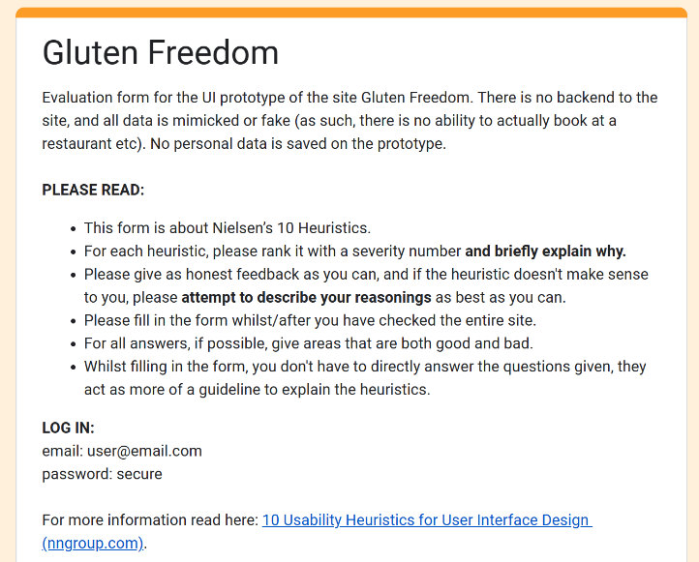As shown, the form first asks for honest feedback and details about responses. It also provides information about what the heuristics are as not everyone who reviewed the website studies on our course.

For each question, I show a 0 to 4 scale, explain what each number represents, and provide information about the relevant heuristic. I also ask for feedback about the usability of the site.

## About the responses

I asked for feedback from 6 people, 3 on our course and 3 who are not. This was an intentional decision as I wanted to see how feedback would differ from those who know what usability elements to look for to those who don’t. One of my participants is colourblind too, meaning I was able to test accessibility further.

## Example question

For all my heuristics, I included some sample questions to help the users understand what the heuristics mean. An example question is shown below:

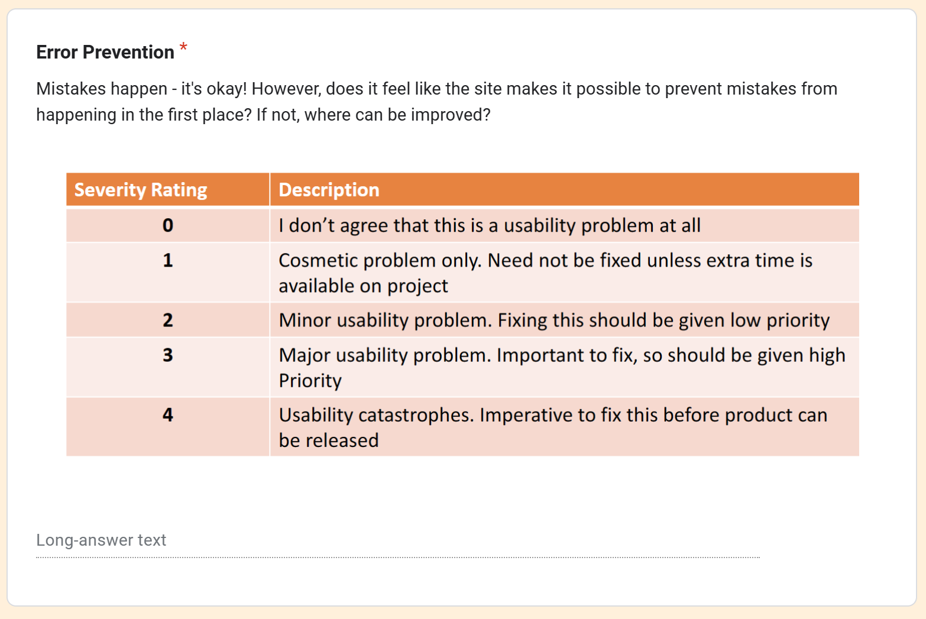

## The heuristics and their ratings

Below is the list of the heuristics, the rankings they received, and the additional feedback I got along with them.

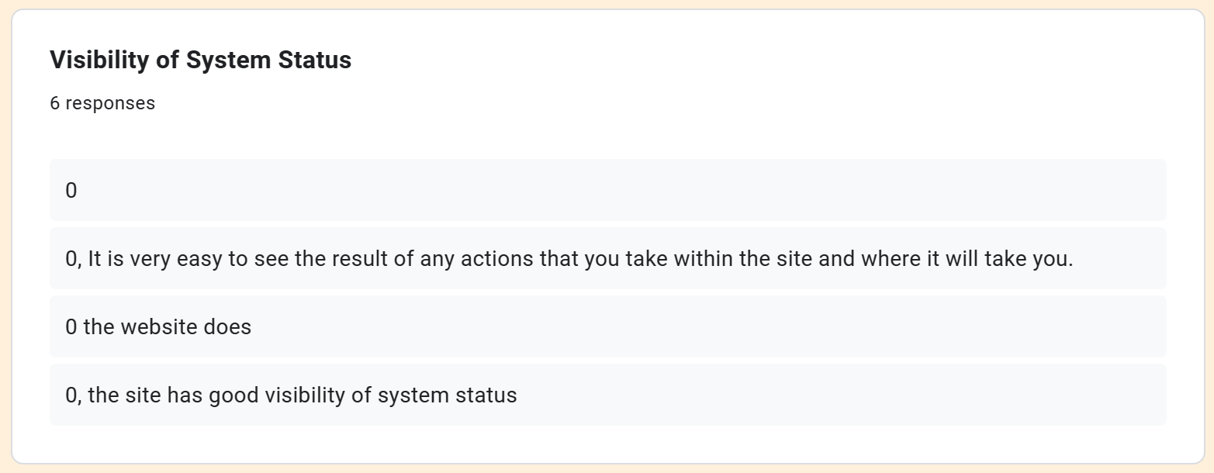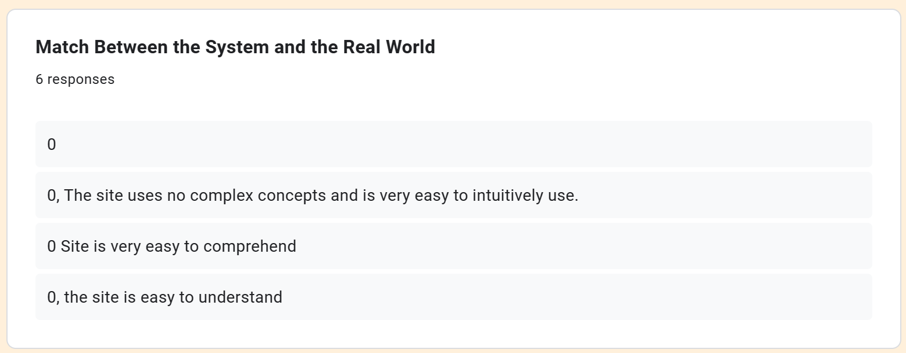

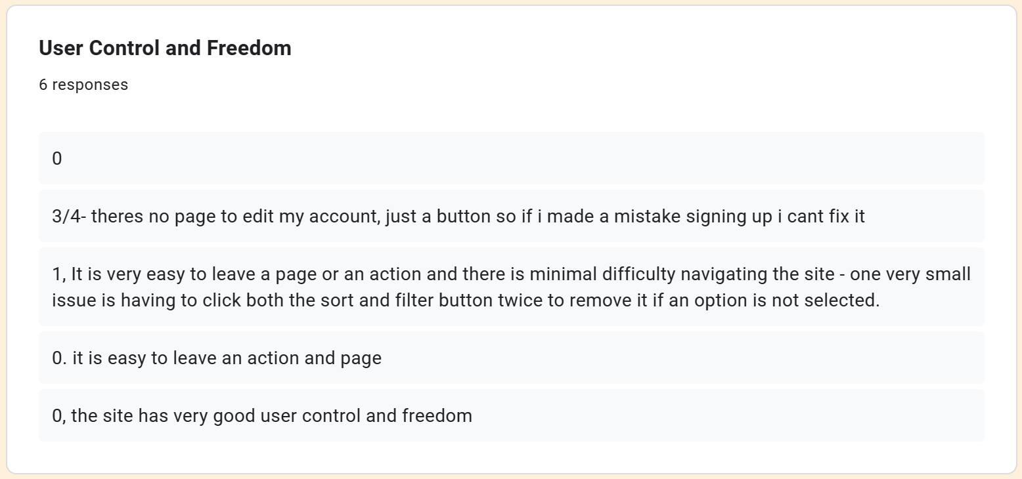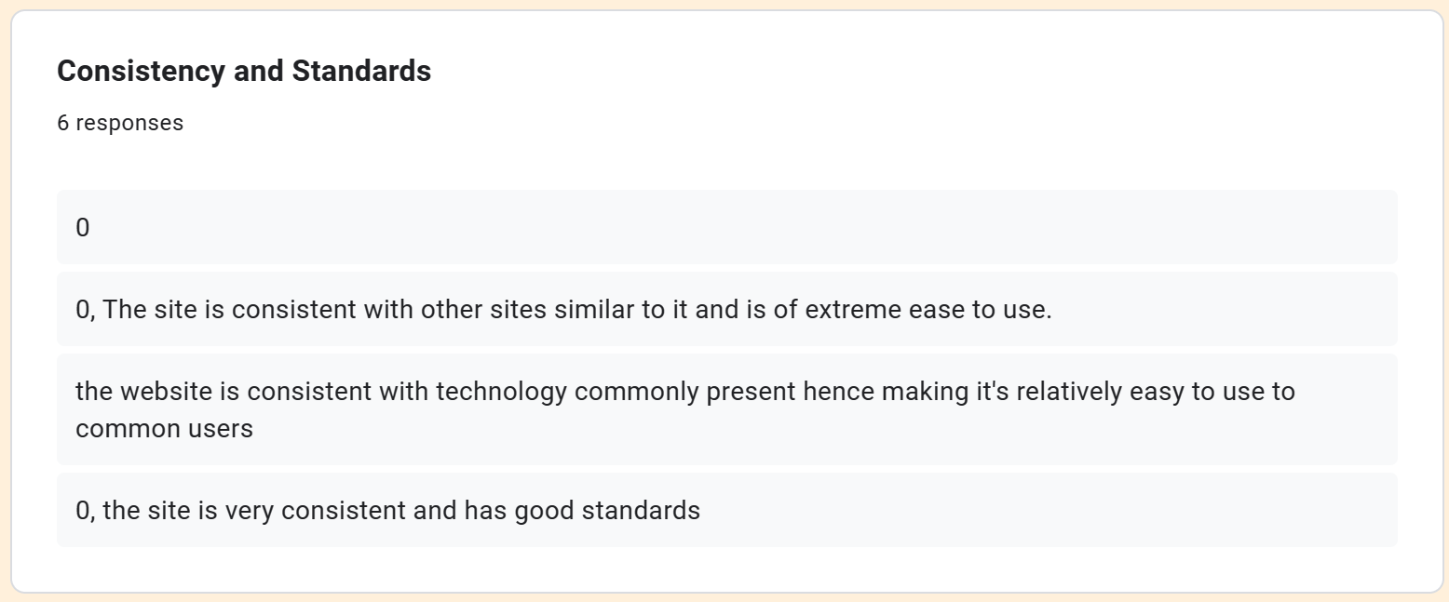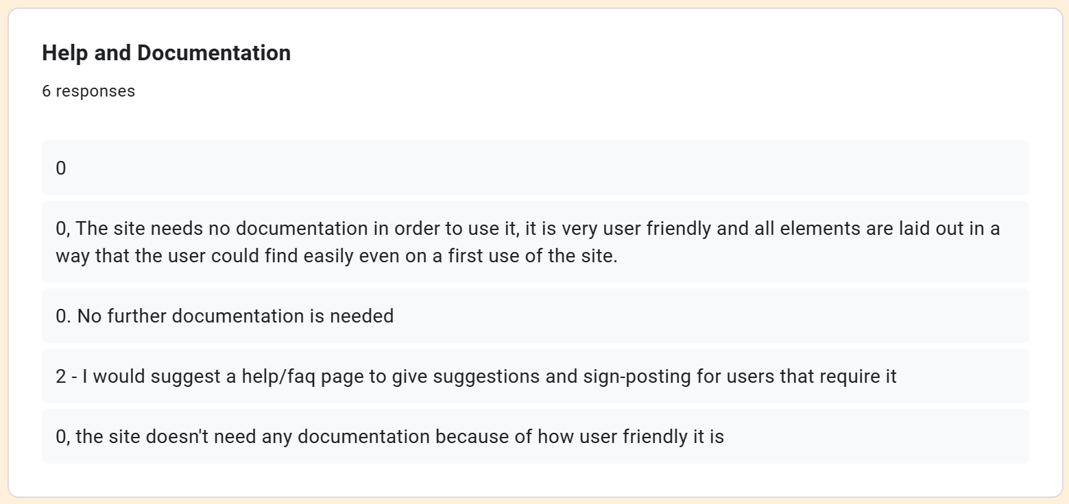

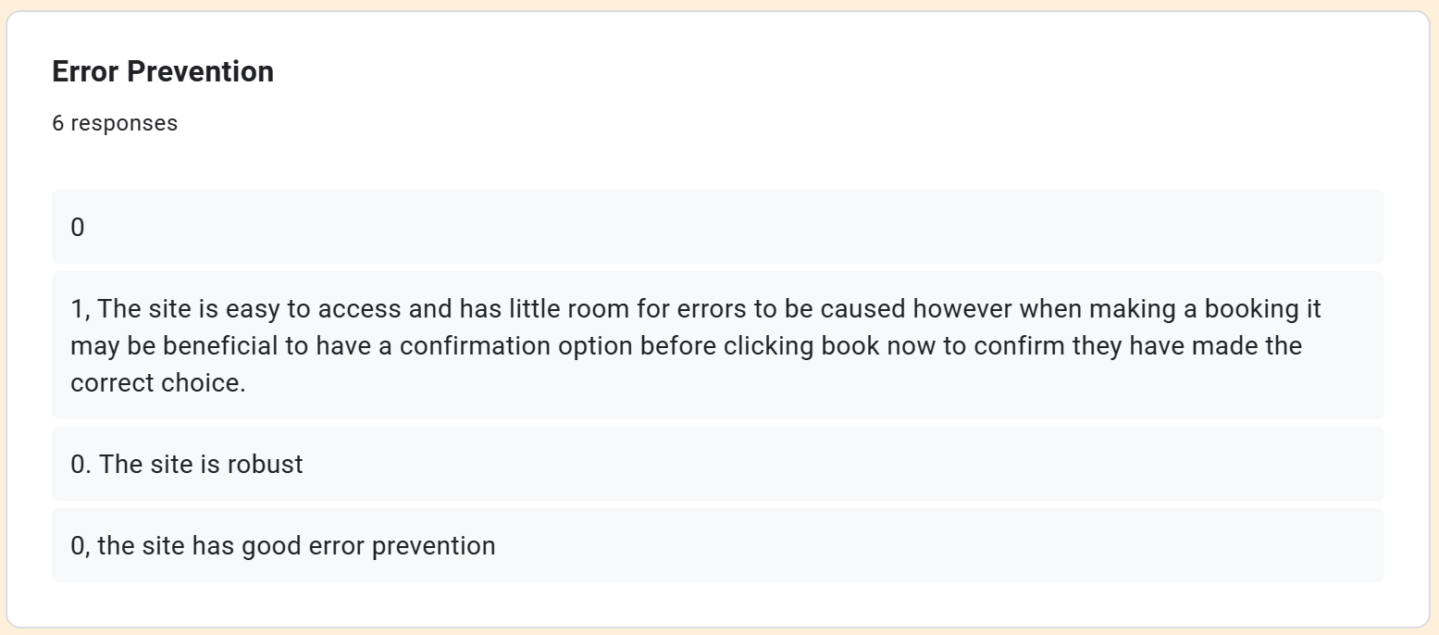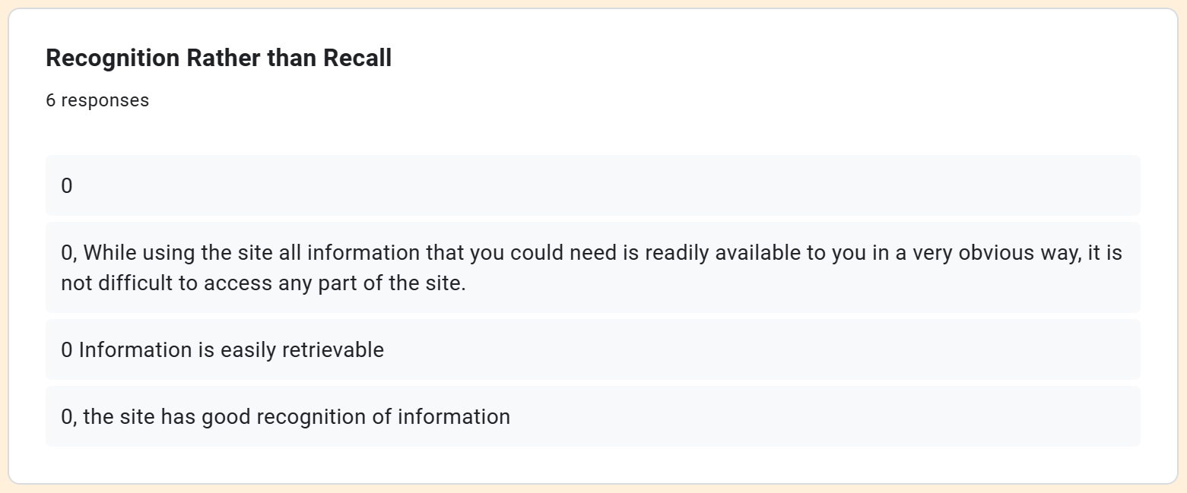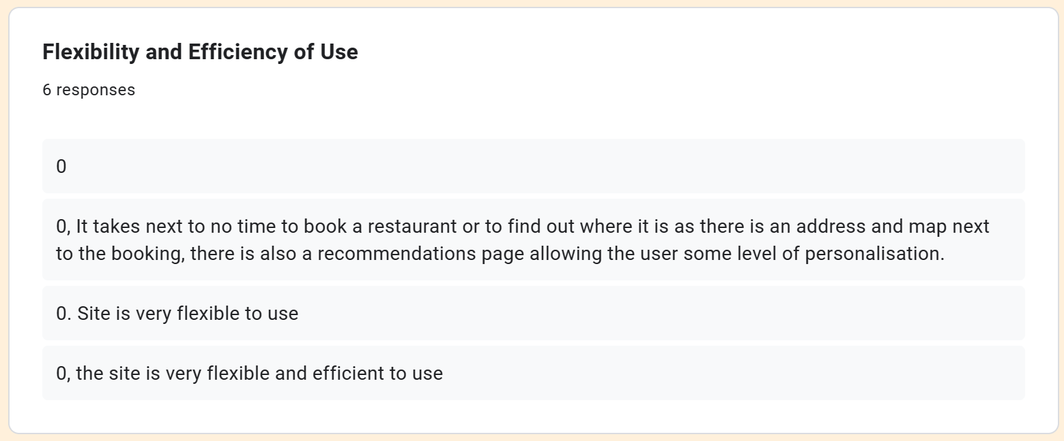 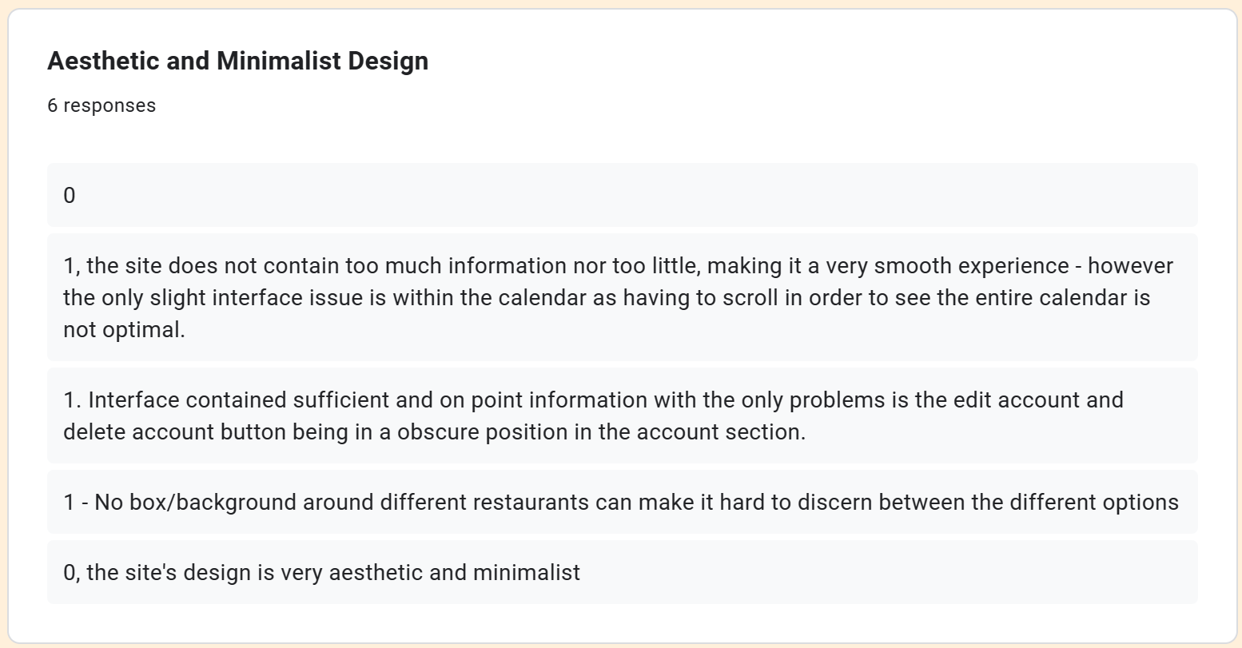 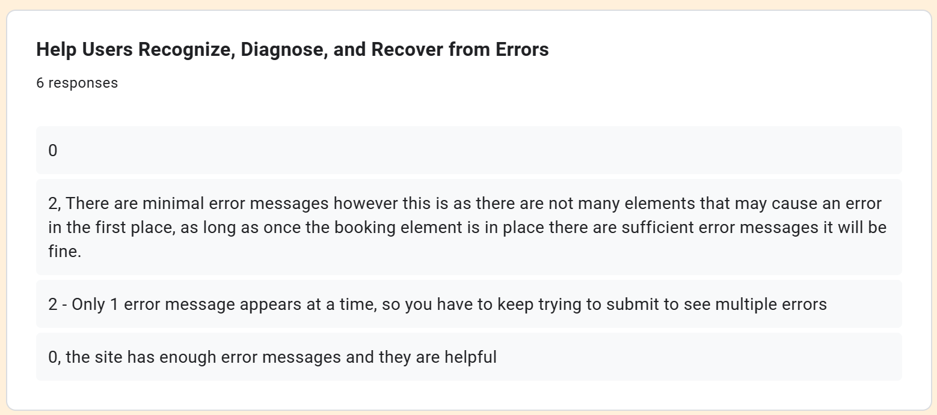 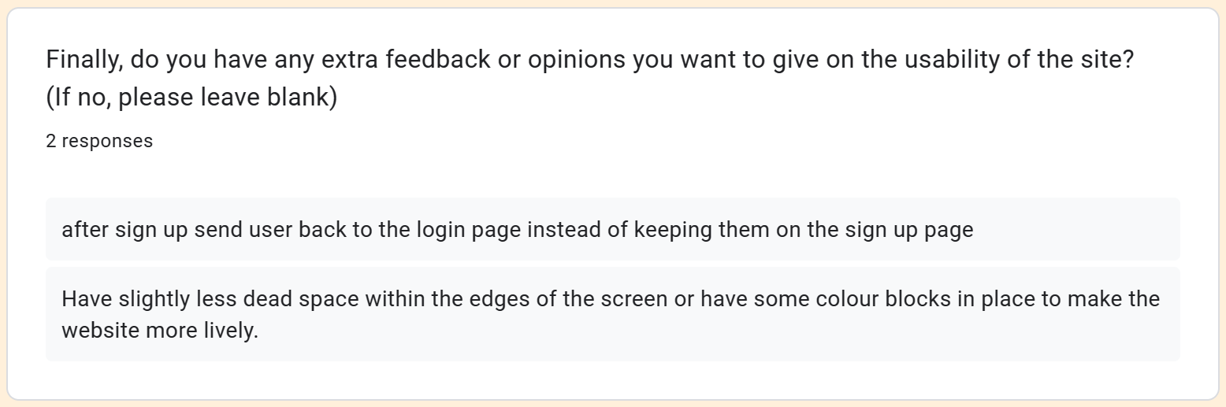

# Feedback Discussion

## Visibility of System Status

All feedback I received about this heuristic was positive, with all rankings being 0 for any problems. Specific feedback I received was that it is easy to see the result of any actions you take, and you can clearly understand where a button will lead you.

## Match Between the System and the Real World

Once again, all feedback I received about this heuristic was positive having been given only 0’s for problems. Feedback included that the “Site is very easy to comprehend” and “The site uses no complex concepts and is very easy to intuitively use.” As such, I am happy with this part of the site and don’t consider there to be any changes I should make.

## User Control and Freedom

Majority of the feedback for this heuristic was positive. My most negative feedback was a rank 3/4 for the fact the “Edit Account” button on the Account page doesn’t take the user to a page to edit the account. However, in a live version of the website there would be one, but for the sake of the prototype it was left out, so whilst this feedback is appreciated it doesn’t affect the current prototype. Other feedback I received was that you need to double click to close the sort and filter dropdowns, otherwise they stay in the way of the screen, which is valid feedback and something that can be implemented easily. All other feedback received is the site is easy to use.

## Consistency and Standards

All feedback received was positive, and I only received severity rankings of 0. The feedback told me my website was consistent with the standard of other sites and is therefore easy to use. As such, I am happy with the general layout of the site and don’t feel the need to alter this aspect of the website.

## Error Prevention

One piece of feedback I got was ranked with a severity of 1. It said that whilst the site is easy to access, when making a booking it would be beneficial to have a confirmation option. As I didn’t add the booking feature in the site as it would be connected via the websites original booking system, the user is right to say a confirmation feature technically does not exist. However, if the site was live and had a booking system that worked alongside the restaurants, a confirmation screen would be added. Other than this, all feedback received was overwhelmingly positive, with only severity rankings of 0.

## Recognition Rather than Recall

All feedback received was overwhelmingly positive with only severity rankings of 0. I was informed that all information is readily available, not difficult to access, and contained a good amount of information in places that it was expected to be.

## Flexibility and Efficiency of Use

Yet again, I received only 0’s for severity rankings, highlighting that my site is flexible and efficient to use. One piece of feedback I received mentioned how it is simple to book at a restaurant and find the locations of them. The same piece of feedback highlighted the recommendations page as a way of adding personalisation.

## Aesthetic and Minimalist Design

For this heuristic, I received three 1’s for severity ranking. The first feedback mentioned that the site contains a good amount of information and that it was a smooth experience, but that the calendar interface is too long and requires users to scroll to see the entire thing. This can be solved by altering the design of the calendar to fit the users screen better. With my current experience using FullCalendar, I don’t have the knowledge to currently change this, but it is something I will look further into.

Other feedback alerted me that there were visual issues with the ‘Delete Account’ and ‘Edit Account’ button on the Account page. My formatting had caused the buttons to overlap onto text. This is a relatively easy fix for me to look into which I will update for my final website.

Finally, I received feedback that no box around the different restaurant options makes it slightly hard to distinguish between them. To change this, I will look at adding borders between each option to help make them visually distinguishable.

All other feedback I received had a severity rating of 0.

## Help Users Recognize, Diagnose, and Recover from Errors

For this heuristic, I received four severity rankings of 0, but two severity rankings of 2.

The first 2 severity ranking said that there were minimal error messages. However, the feedback also acknowledged that there aren’t actually enough places to cause errors hence the lack of error messages for the time being isn’t an issue.

The second 2 severity ranking discussed the fact that only one error message appears at a time when submitting a log-in/sign-up form. As I had created the errors using HTML’s built-in error recognition, it would be difficult to change without sacrificing the visual elements that the built-in recognition provides. Whilst I understand the singular error messages could be annoying, as the forms are so short and simple, I would rather choose to keep the visual elements that support those who have sight impairments.

## Help and Documentation

For this heuristic, I received one severity ranking of 2. The feedback along side it suggested adding a help page (since I currently lack one) and signposting it for users. However, all other feedback I received stated that the site didn’t need any help documentation to use it as it is already a very user-friendly site with clear navigation. Whilst most of the feedback stated I didn’t need a help page; I still believe it would be beneficial to add one even if only one person needs it. In order to add one, I would commit some time into researching where any potential confusion and support would be needed to ensure that my help documentation actually benefits the users.

## Extra Feedback

One piece of feedback I received was that I ought to have less white dead space between the edge of the screen – or at least replace it with some colour. I agree firmly with this feedback, as having less dead space means I can expand the centre of the page. Therefore, I can increase the font size used, or allow for the option for users to increase text size. This would improve upon the accessibility of the site.

Another piece of feedback I received was for the sign-up page to send the user to the login page rather than keep them on the sign-up page. This is a small change I will implement.

# Conclusion

For this coursework, I created the front end for a website that focuses on gluten free restaurants in Bristol. In my opinion, this was implemented successfully, with my feedback being largely positive and all my critiques being small and easily implementable changes. To make the change from this being a prototype to a live website, I would look at working alongside businesses and creating a booking system that updates both my site and their system. I would also include the collection of user locations on the condition the users allow this data to be stored. From this information, I would then show on the maps where the user is in comparison to the restaurants.

# References

FullCalendar. (2024, January 27). *Docs/Accessibility*. Retrieved from https://fullcalendar.io/docs/accessibility

Google. (2024, May 3). *Make markers clickable and accessible*. Retrieved from https://developers.google.com/maps/documentation/javascript/advanced-markers/accessible-markers?_gl=1*ufcaj0*_up*MQ..*_ga*MTM4MjQwMjgzNC4xNzE1NDU2MTU1*_ga_NRWSTWS78N*MTcxNTQ1NjE1NS4xLjAuMTcxNTQ1NjM3MC4wLjAuMA..

Shull, C. J. (2021, June 15). *Improved accessibility in the Maps JavaScript API*. Retrieved from https://mapsplatform.google.com/resources/blog/improved-accessibility-maps-javascript-api/

Singleton, J. (2021, August 9). *ACCESSIBILITY TESTING AND IFRAMES*. Retrieved from https://convergeaccessibility.com/2021/08/09/accessibility-testing-and-iframes/

WCAG. (2021, January 12). *What is WCAG*. Retrieved from https://wcag.com/resource/what-is-wcag/

WebAIM. (2020, September 24). *Creating Accessible Frames and Iframes*. Retrieved from https://webaim.org/techniques/frames/#:~:text=There%20are%20no%20distinct%20accessibility%20issues%20with%20inline,even%20support%20navigating%20them%20along%20with%20standard%20frames.